January 3,2025
Jewish Federations of Canada – UIA Regional Jewish Communities of Canada
NEWSLETTER
Sudbury hosts its first-ever public menorah lighting
‘The solution to anti-Semitism is not to hide,’ Shaar Hashomayim Synagogue board president Emily Caruso Parnell told Sudbury.com following Friday’s menorah lighting ceremony
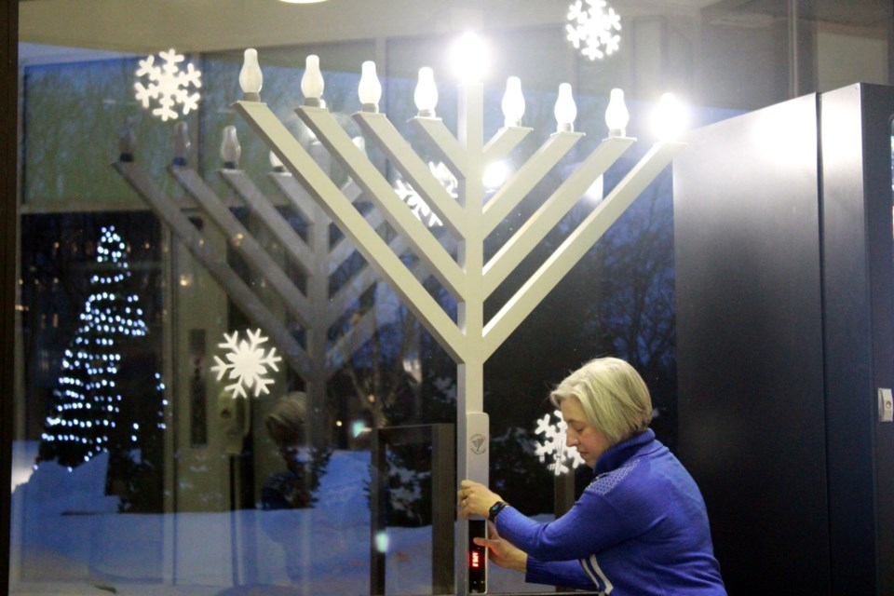
Shaar Hashomayim Synagogue board president Emily Caruso Parnell “lights” a giant menorah at Tom Davies Square during a ceremony on Friday. Tyler Clarke
Sudbury hosted what is believed to be the city’s first public menorah lighting ceremony at Tom Davies Square on Friday.
Sudbury hosts its first-ever public menorah lighting - Sudbury News
==========================================================
How Barrie is celebrating Hanukkah

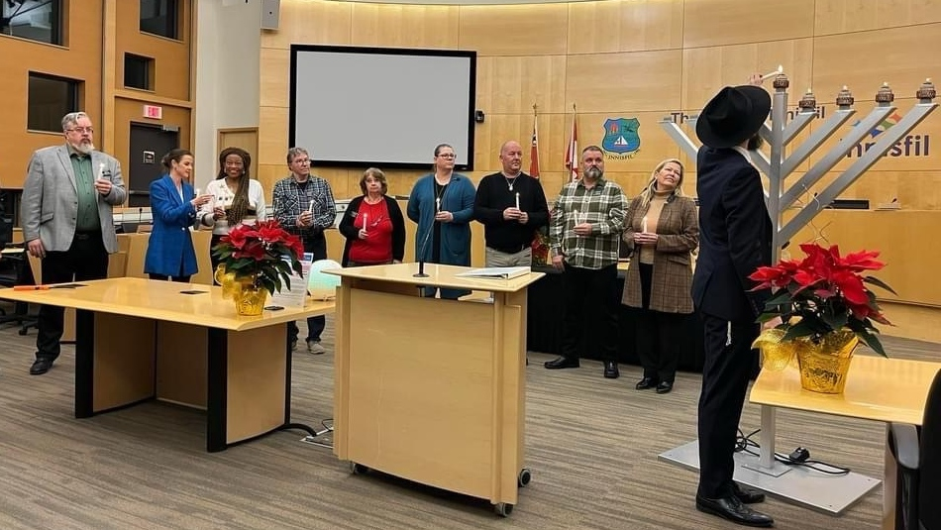
Rabbi Zev Kaplan (far right) lighting the grand hanukkiah at Town Hall along with Town officials for the fourth night of Hannukah in Innisfil, Ont., on Sun., Dec. 10, 2023 (Source: Chabad Innisfil/Supplied)
https://barrie.ctvnews.ca/how-barrie-is-celebrating-hanukkah-and-kwanzaa-1.7158028
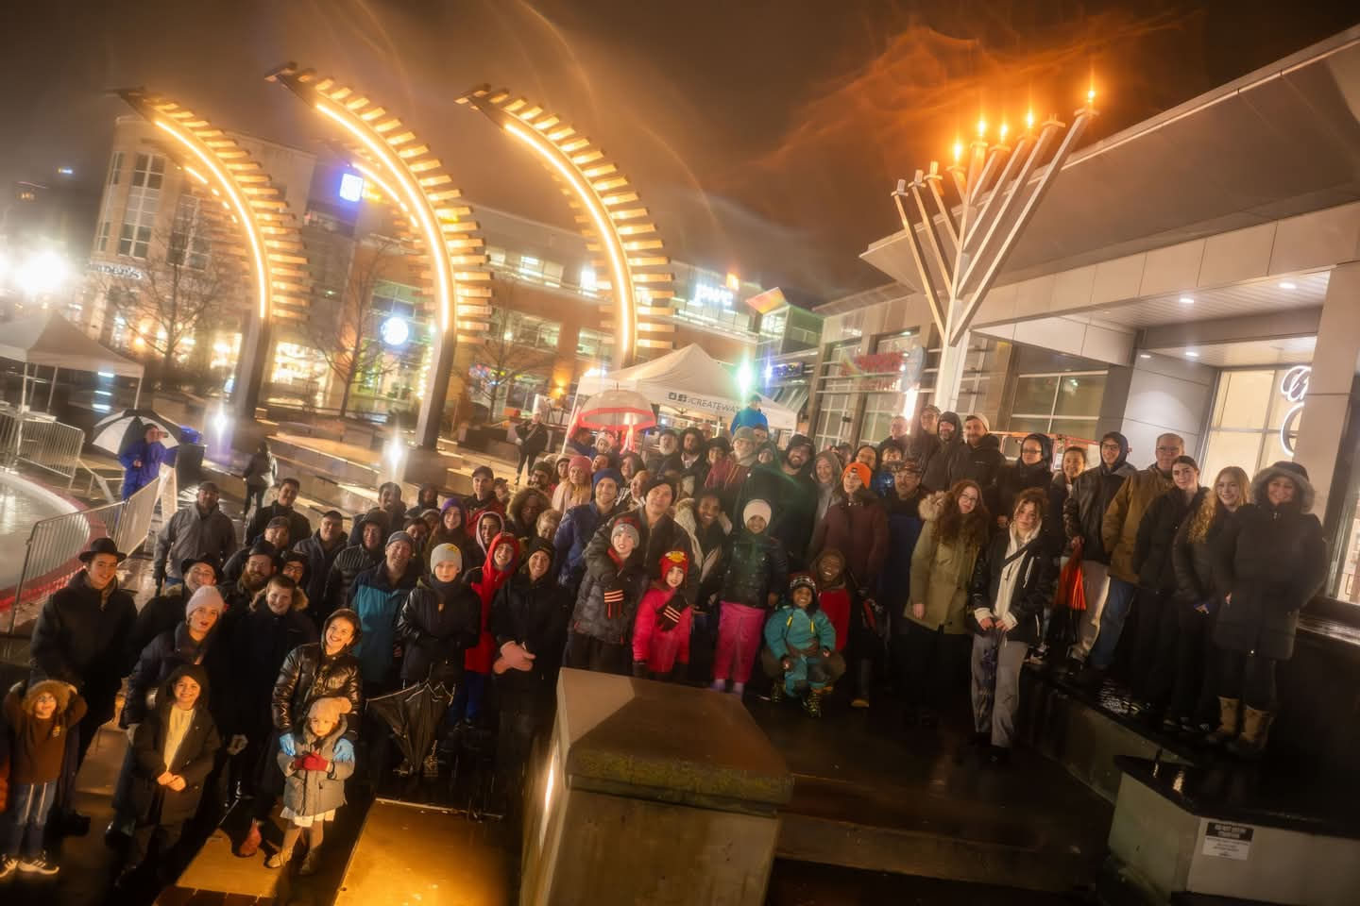
Kitchener-Waterloo celebrates Chanukah with a Menorah lighting at Waterloo Town Square

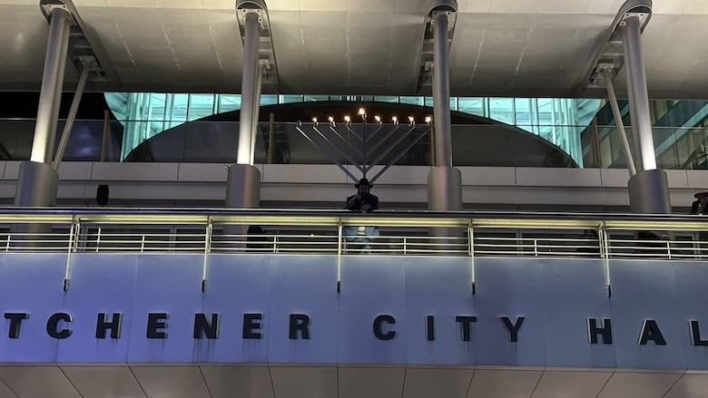
Rabbi Moshe Goldman with The Rohr Chabad Centre for Jewish Life lit the menorah at Kitchener City Hall on the final night of Hanukkah
https://www.cbc.ca/news/canada/kitchener-waterloo/celebrating-hanukkah-in-waterloo-region-and-guelph-1.7418627
==========================================================
Guelph
In Guelph, a nine-foot-tall menorah will be displayed at Market Square outside city hall starting Dec. 26. Rabbi Raphi Steiner, the director of the Chabad of Guelph, told CBC News that everyone is welcome for the festivities which begin at 4:30 p.m.
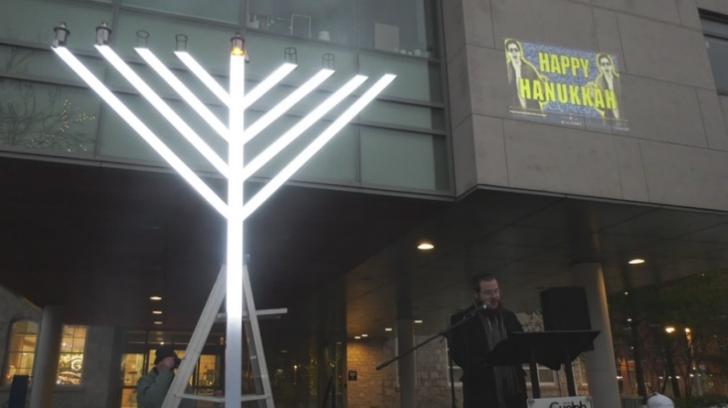
A giant menorah stood in front of Guelph city hall on December 26, 2024 (Sidra Jafri/CTV News)
https://kitchener.ctvnews.ca/giant-menorah-lit-in-guelph-1.7158430
Public lighting Menorah at Moncton (NB) City Hall 5785
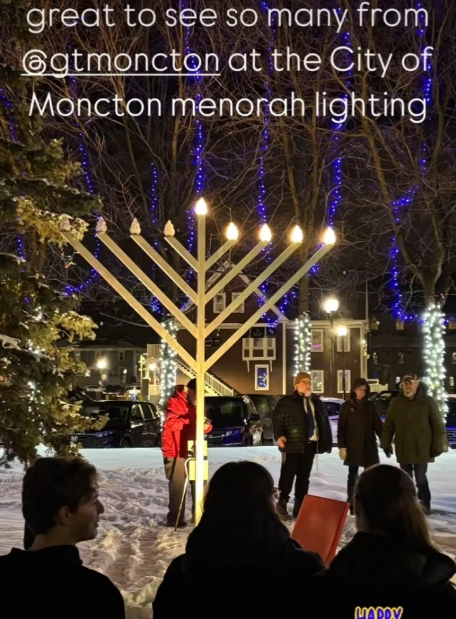
==========================================================

Lighting the Chanukah Menorah in Saskatoon, SK
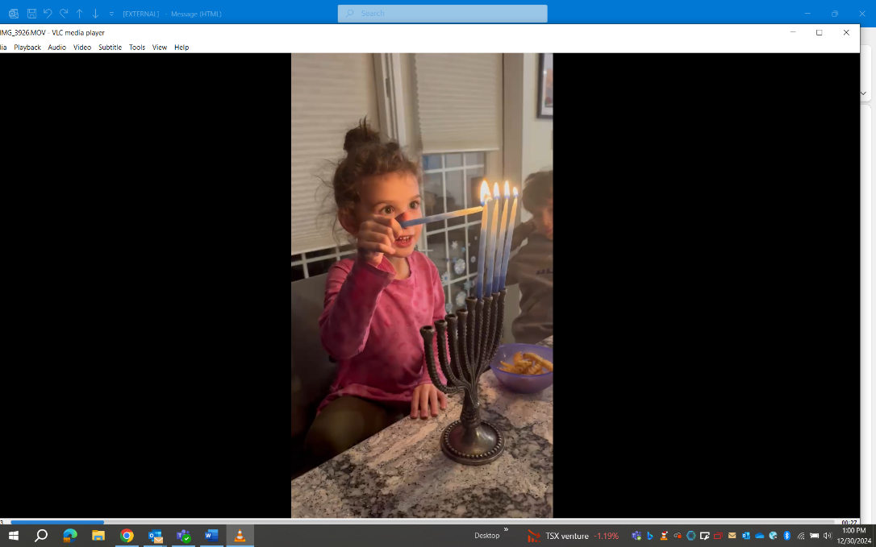
==========================================================
Kingston,ON- The Kingston Jewish Council Light Up The Night Menora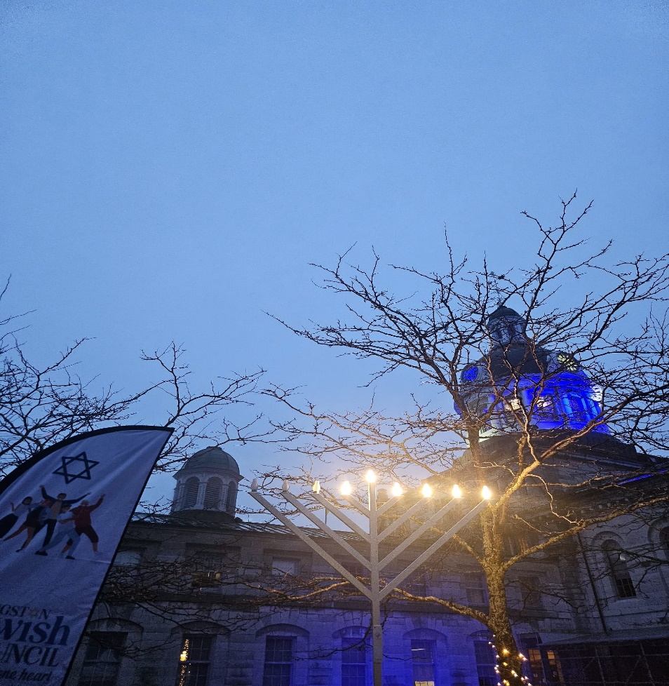h Lighting at City Hall

Kelowna, BC, Chanukah Menorah Candle lighting at City Hall
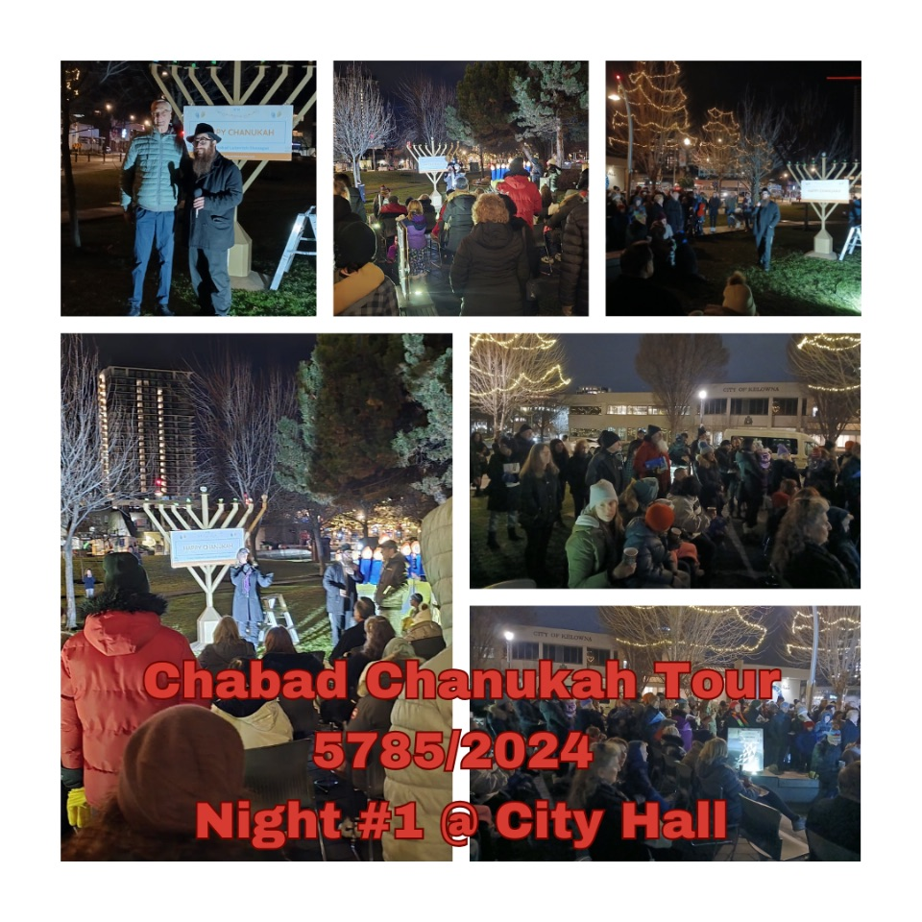
Lighting Chanukah Candles in Duncan and Salt Spring Island, Vancouver Island, BC
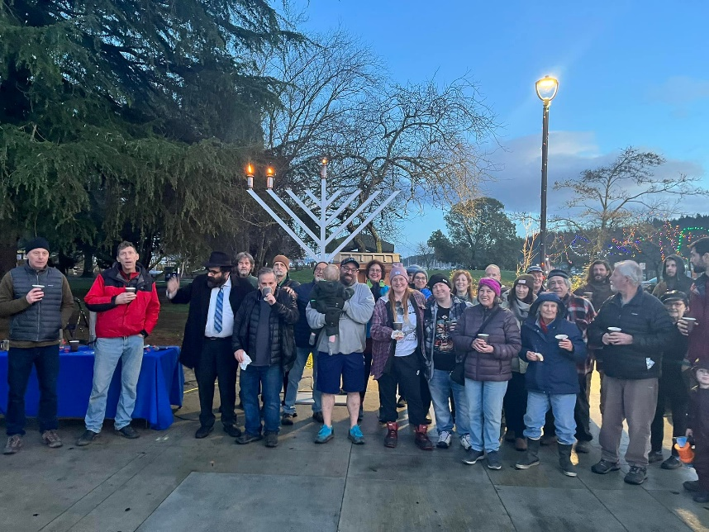
Regina, SK, Beth Jacob Synagogue/The Herman Jewish Community Centre of Regina Celebrate Chanukah 2024
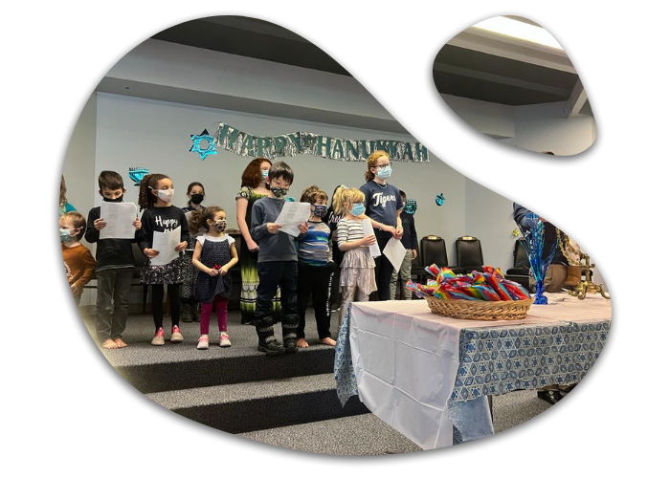
The Jewish Cultural Society of the Yukon/Yukon University
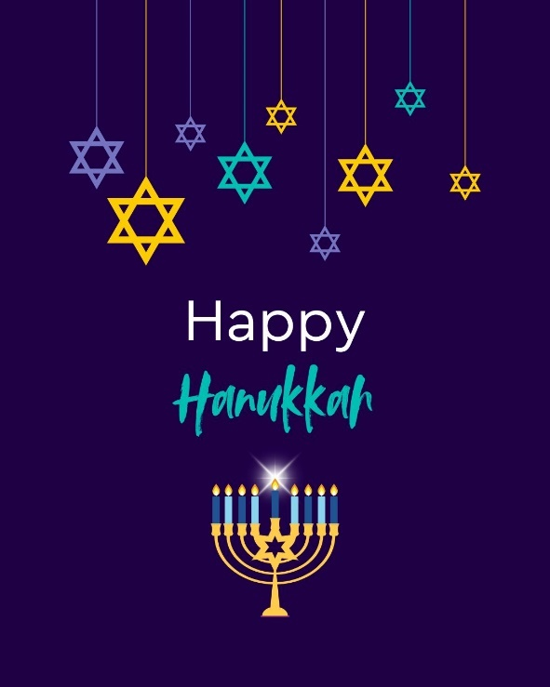

Ice menorah lights up the darkness for northern Hanukkah. Elise Maltin got the idea for the ice menorah while living in Yellowknife and continued it when she moved to Whitehorse.

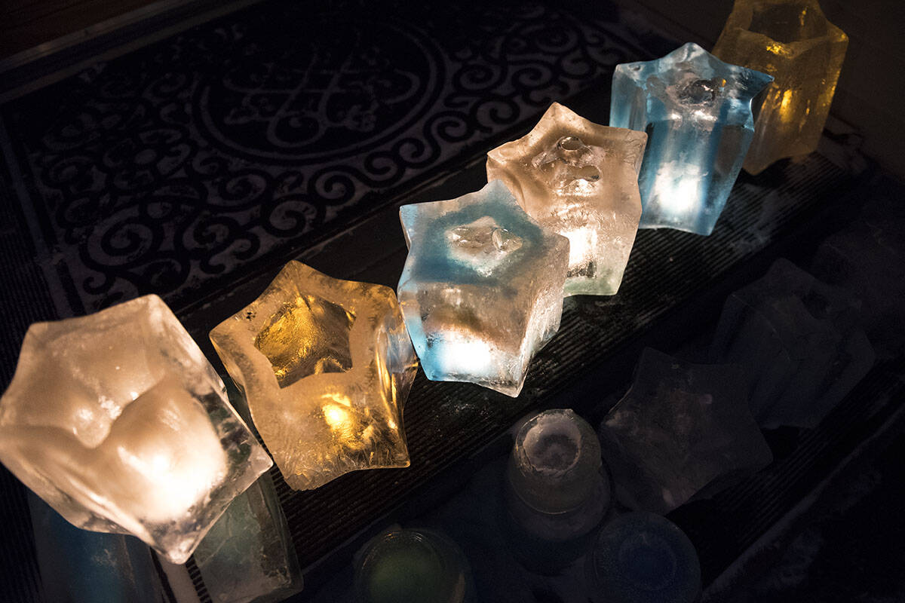
(Haley Ritchie/Yukon News)
==========================================================

GRAND MENORAH LIGHTING at the FALLS
Falls Ave & Niagara Parkway, Niagara Falls, Canada
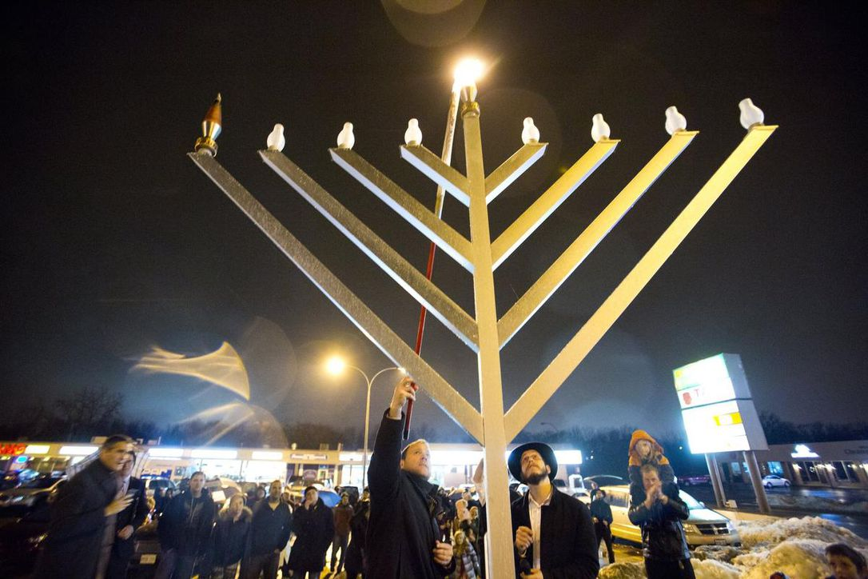

Sault Ste. Marie, ON, Beth Jacob Synagogue Chanukah Menorah Lighting
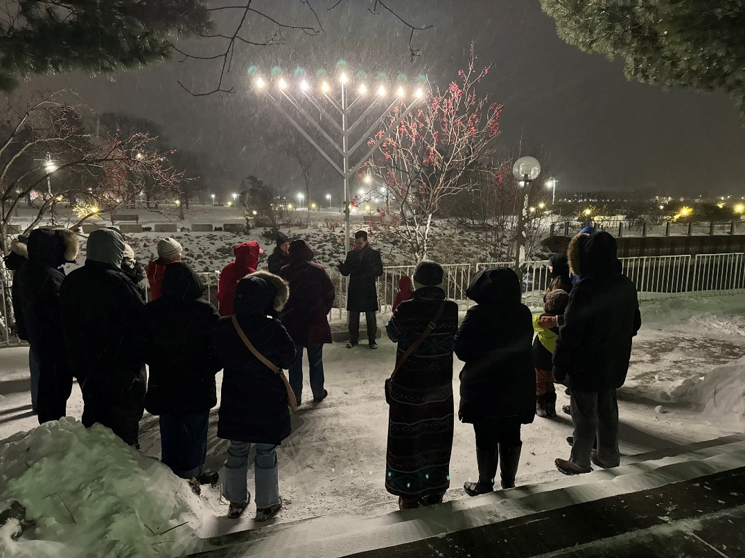
This is Chanukah in Northern Ontario - parkas and chattering teeth didn't stop us from singing the blessings with gusto. I think we all left with warm hearts and joyful spirits.
==========================================================Kamloops, BC-Jewish Community Centre Chanukah 2024 Program
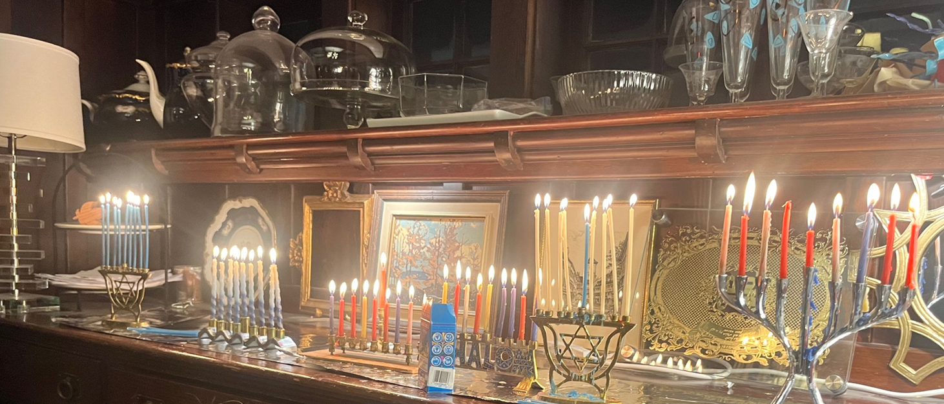

Fredericton, NB
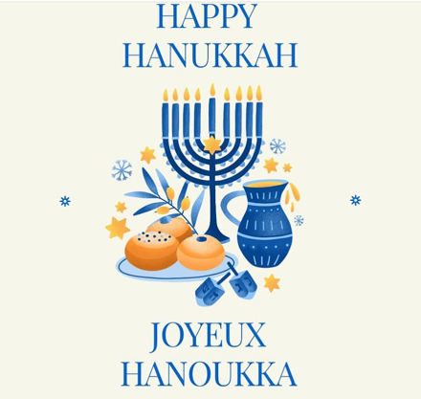
Mayor Kate Rogers, Office of the Mayor of Fredericton
Chag Hanoukka Sameach! On behalf of Fredericton City Council, I would like to wish everyone celebrating, a Hanoukka filled with peace, love and kindness. 🕎🕎
Chag Hanukkah Sameach ! Au nom du conseil municipal de Fredericton, je souhaite à tous ceux qui célèbrent Hanukkah une journée remplie de paix, d’amour et de gentillesse. 🕎🕎

Barrie, ON
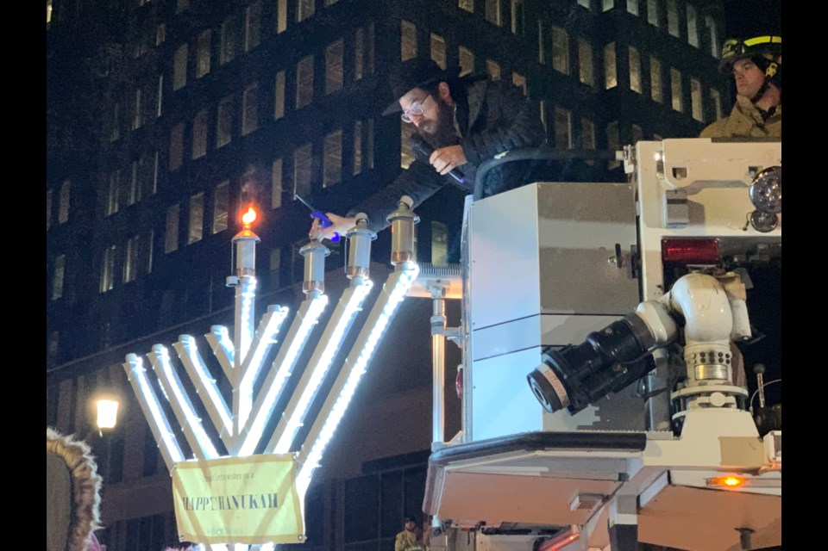
Rabbi Mendel Nakkar, who directs Chabad Jewish Centre of Barrie, lights the candles on a nine-foot menorah for the third night of the eight-day Festival of Lights during a celebration at Barrie City Hall. Nikki Cole/BarrieToday
Belleville, ON
Children paint their own menorahs during the first day of Hanukkah on Dec. 18th inside the Sons of Jacob Synagogue in Belleville, Ontario.
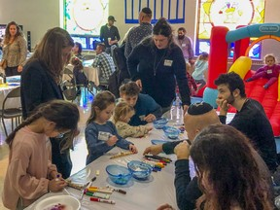
Submitted.



