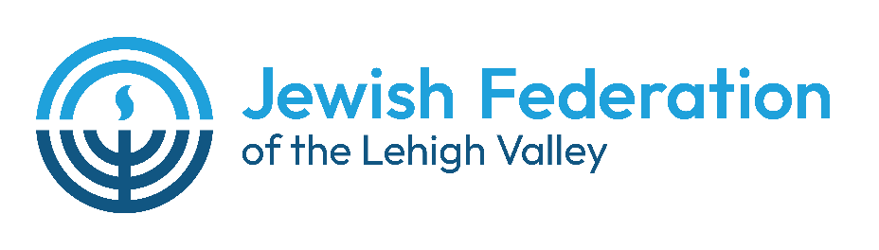

Call for Entries from 10th, 11th, and 12th Graders:
Max “Maggie” Levine Essay Contest
for Alexander Muss High School in Israel Scholarship

The Jewish Federation of the Lehigh Valley is pleased to announce the Annual Maggie Levine Essay Contest. Max “Maggie” Levine was an active member of both the JFLV Board and staff. He is remembered for his hard work and dedication, inspirational enthusiasm and great energy that were reflected in all his endeavors on behalf of the Federation, the Jewish and general communities, and the state of Israel.

The essay contest, established to recognize an outstanding essay submitted by a teenager interested in enrolling in the Alexander Muss High School in Israel (AMHSI), is open to all Jewish 10th, 11th, and 12th graders. The winner(s) will receive a generous prize toward the cost of the AMHSI program. The theme of the essay should address “How Israel is part of my Jewish identity and/or how the High School in Israel experience will help shape my relationship with Israel.”

Deadlines for the essays are as follows:
March 20, 2026 for summer 2026 program
July 3, 2026 for 2026-27 school year program
March 19, 2027 for summer 2027 program

Essays should be submitted to the Federation office, contain between 500 and 1,200 words, and be typed and double-spaced. Electronic submission in Microsoft Word is preferred to jeri@jflv.org. Essays must be deemed worthy and meritorious to be considered; they will be reviewed by a panel of judges whose decision is final. The committee reserves the right not to make an award presentation if the submitted essays do not meet the high standards of the committee.

For more information about the Alexander Muss High School in Israel program, visit their website at amhsi.org or contact Jeri Zimmerman at the Jewish Federation of the Lehigh Valley at 610-821-5500 or jeri@jflv.org.

For more information about the Maggie Levine Essay Contest, contact Jeri Zimmerman, JFLV Executive Director, at 610-821-5500 or jeri@jflv.org.

The funds for the Maggie Levine Essay Contest are provided by the Lehigh Valley Jewish Foundation, the Jewish community’s endowment program of the Jewish Federation of the Lehigh Valley.

