JEWISH FEDERATION OF THE LEHIGH VALLEY
presents
MISSION TO ARGENTINA
Buenos Aires • Bariloche
Tuesday, March 16 – Friday, March 26, 2027

An eleven-day journey through Jewish history, culture,
community life, and the natural beauty of Patagonia

ITINERARY OVERVIEW

TRAVEL Nonstop flight from JFK to Buenos Aires
DAY 1 Wednesday, March 17  BUENOS AIRES — ARRIVAL  Group arrival transfer  11:00 AM Visit Avenida de Mayo, the first avenue in the city of Buenos Aires, and the Plaza de Mayo, surrounded by the Casa Rosada (Government House), the Metropolitan Cathedral, and the Cabildo (the first City Hall).  Walk to the Cathedral, where Pope Francis celebrated services when he was Cardinal of Buenos Aires.  1:00 PM Group lunch at a local restaurant with guest speaker Andrés Borenstein, who will give a brief history of Argentina — its politics, economics, and the Jewish community. Borenstein is a prominent Argentine economist and professor, holding a master's in finance from Universidad Torcuato di Tella (2002), with years of experience in industry, academia, and as a subject matter expert commentator for various media outlets.  *Potential ceremony at the Israeli Embassy remembering those killed in the terrorist attack of 1992, estimated 2:30–4:00 PM. The ceremony would be in Spanish, so a translator would be needed.  4:00 PM Check-in at the hotel.  7:00 PM Group Welcome Dinner.  11:00 PM Return to the hotel. | 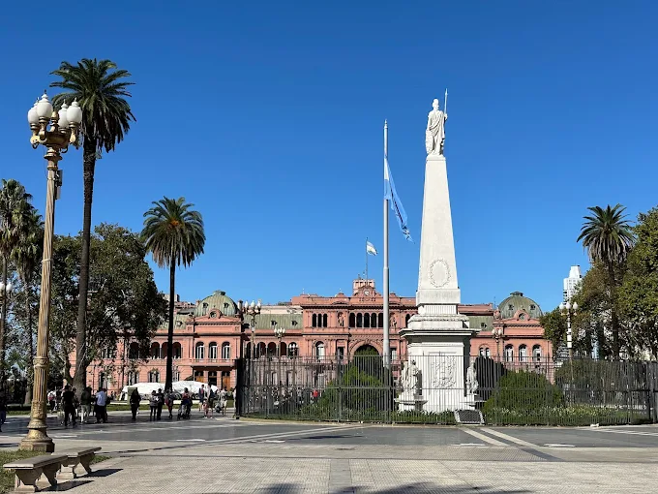  Plaza de Mayo & Historic Center
OVERNIGHT Hilton Buenos Aires
DAY 2 Thursday, March 18  BUENOS AIRES — JEWISH HERITAGE & NEIGHBORHOODS  9:00 AM Depart hotel. Drive through the “Once” neighborhood — home to the largest Jewish population in the city and most of its Jewish institutions, including the Hebraica JCC, synagogues, schools, and the only kosher McDonald's outside of Israel.  10:00 AM Tour AMIA, the main Jewish institution in Buenos Aires. AMIA works to strengthen educational environments that guarantee continuity and reflect the diversity of the Jewish-Argentine community, with deep ties to Israel and Jewish communities worldwide, encouraging the observance of Jewish tradition and cultural heritage. The tour includes a visit to the memorial devoted to the 89 victims of the 1994 bombing, built by world-famous artist Yaacov Agam. The group will meet with JAFI representatives at AMIA and learn about their projects across the country.  12:30 PM Group lunch at Al Galope Kosher Steakhouse.  2:30 PM Drive to La Boca, a colorful neighborhood home to the famous Caminito Street and Boca Stadium (home of Boca Juniors, one of South America's most storied soccer clubs). Walking tour of Caminito Street, filled with local painters offering their tango-inspired art and tango dancers, with time for shopping.  Proceed to San Telmo, the best-kept historic neighborhood and oldest district of Buenos Aires.  5:00 PM Return to the hotel.  6:00 PM Depart the hotel for an evening of Tango — dinner and a show that combines movement, color, sound, and the sensuality of one of the best tango shows in town. | 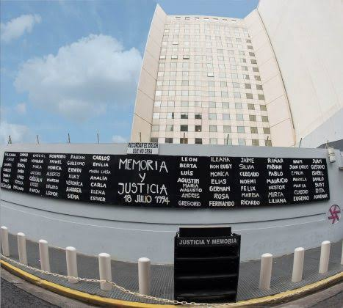  The AMIA Memorial
OVERNIGHT Hilton Buenos Aires
DAY 3 Friday, March 19  BUENOS AIRES — EDUCATION, JDC & SHABBAT  8:30 AM Depart hotel to visit an ORT school for Jewish education, created to support the influx of refugees and meet the country's need for skilled workers.  11:30 AM Make your own lunch- a culinary demonstration followed by lunch  3:00 PM Tour the Teatro Colón Opera House, widely considered one of the finest theaters in the world and acclaimed for its acoustics and architecture. It celebrated 100 years of performances in 2008, having been inaugurated on May 25, 1908 with Giuseppe Verdi's opera Aida.  5:00 PM Return to the hotel. Freshen up before Shabbat.  6:30 PM Depart for Kabbalat Shabbat services at Amijai Synagogue, followed by dinner at a local restaurant.  11:00 PM Return to the hotel. | 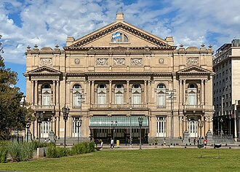  Teatro Colón
OVERNIGHT Hilton Buenos Aires
DAY 4 Saturday, March 20  BUENOS AIRES — SHABBAT & LEISURE  Enjoy breakfast at the hotel.  Spend the day at Club Náutico Hacoaj, a Jewish country club — meet with Board members and enjoy the facilities.  6:00 PM Return to the hotel. Evening at leisure. | 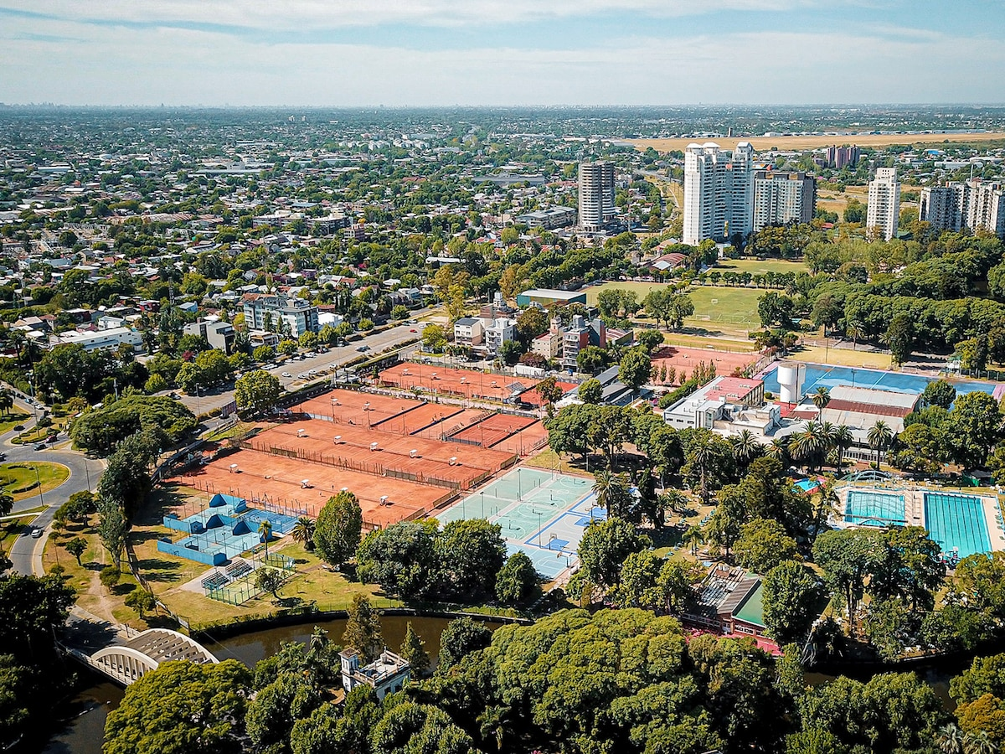  Club Náutico Hacoaj
OVERNIGHT Hilton Buenos Aires
DAY 5 Sunday, March 21  BUENOS AIRES TO BARILOCHE  Enjoy breakfast at the hotel. Transfer to Aeroparque Airport for the flight to Bariloche.  BARILOCHE Llao Llao Resort — Studio Lago Moreno Room  Arrive in Bariloche, a picturesque mountain town nestled along the shores of Lake Nahuel Huapi in the heart of Argentina's Lake District. Transfer to the hotel and settle in — the remainder of the day is at leisure to rest, relax, and take in the stunning lake and mountain scenery. | 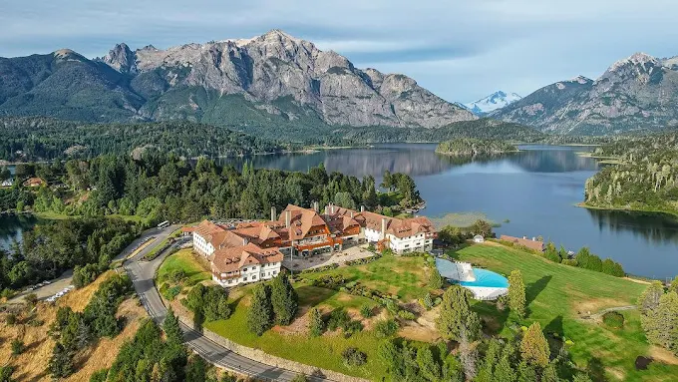  Lake Nahuel Huapi & the Lake District
OVERNIGHT Llao Llao Resort, Bariloche
DAY 6 Monday, March 22
BARILOCHE HIKING
After breakfast, meet your guide for a full day of hiking through the stunning landscapes of Bariloche. Whether you're looking for a challenging trek or a more relaxed scenic outing, this flexible day lets you choose the adventure that suits you best. Options include:
- Bariloche Vistas (4 miles combined, mostly flat) — A relaxed, scenic drive along the famous Circuito Chico with short, easy hikes to some of the area's most breathtaking viewpoints. Perfect for travelers who want to soak in the beauty without a strenuous hike.
- Cerro Goye Hike (6 miles, 2,400' elevation gain) — A moderately difficult climb through native forest to panoramic views of Lake Moreno and surrounding peaks, ending with a visit to Colonia Suiza, a charming villa with a handcrafts market and ever-present micro-breweries.
- Frey Loop Hike (8 miles, 3,000' elevation gain) — A full-day alpine circuit through rugged terrain and past dramatic rock spires, with a visit to the iconic Frey hut. Ideal for experienced hikers seeking a classic Patagonian challenge.
Your guide will provide insight into the local environment, geology, and culture as you explore the heart of Argentine Patagonia. (B, L)
Guide ratio: 1 guide to 8 hikers
OVERNIGHT Llao Llao Resort, Bariloche

DAY 7 Tuesday, March 23
BARILOCHE HIKE & KAYAK
After breakfast, meet your guide for a multisport exploration of the Lakes District. Start the day with a short drive to the launch point, where a kayak guide will lead the group across the deep blue waters of Lake Nahuel Huapi or Lake Moreno. In the afternoon, hike the scenic Tristeza Inlet trail — an easy path leading to a granite dome with sweeping views of glaciated Mount Tronador and the 12-mile-long inlet below. (B, L)
Kayaking: 2 to 3 hours | Hiking: 5 miles, mostly flat
Guide ratio: 1 guide to 5 kayakers and 1 guide to 8 hikers
OVERNIGHT Llao Llao Resort, Bariloche
DAY 8 Wednesday, March 24
VILLA CATEDRAL BIKE TOUR
Explore the stunning landscapes surrounding Bariloche on a half-day cycling adventure around Cerro Catedral. Choose between a traditional mountain bike or an electric bike to tailor the experience to your preferred level of challenge and comfort. The route combines scenic paved roads, quiet dirt tracks, and forested trails, with beautiful views of the Andes and the surrounding countryside. Along the way, visit Villa Catedral, Bariloche's renowned mountain village and ski resort, with time to relax and enjoy a beer, coffee, or other refreshment before continuing the ride. The approximately three-hour excursion can be customized to match your experience level, fitness, and desired pace. At the conclusion of the ride, meet your vehicle for the return transfer to Bariloche. (B)
*Both e-bikes and regular bikes will be available.
Guide ratio: 1 guide to 8 bikers; support vehicle available for those on regular bikes
OVERNIGHT Llao Llao Resort, Bariloche
DAY 9 Thursday, March 25
BARILOCHE — BUENOS AIRES — DEPARTURE
Take the morning to relax in this mountain town before the afternoon transfer to the airport for the flight to Buenos Aires. (B)
Evening flight: Buenos Aires → JFK.
Key: (B)reakfast (L)unch (D)inner

LLAO LLAO SPA
Time at leisure in Bariloche — Days 5–9
- Full-service spa with treatments drawing on the surrounding Patagonian landscape
- Indoor pool, sauna, and steam room for relaxation between excursions
- Massage and body treatments — advance reservations recommended
- A quiet complement to the more active days on the itinerary
Details subject to change — confirm current offerings at llaollao.com/en/spa
RESORT INDOOR ACTIVITIES
Time at leisure in Bariloche — Days 5–9
- Heated indoor pool and fitness center
- Indoor games and lounge spaces for downtime with the group
- A comfortable option on days when weather limits time outdoors
- Great for families or anyone pacing themselves between hikes
Details subject to change — confirm current offerings at llaollao.com/en/resort-indoor-activities
PATAGONIA OUTDOOR ACTIVITIES
Time at leisure in Bariloche — Days 5–9
- Golf on the resort's renowned course overlooking Lake Nahuel Huapi
- Horseback riding through the surrounding forest and lakeshore trails
- Tennis, mountain biking, and lake excursions beyond the group itinerary
- A flexible way to extend the adventure on any unscheduled hours
Details subject to change — confirm current offerings at llaollao.com/en/patagonia-outdoor-activities

APPROXIMATE COST

Approximately $9,000 per person
Included in this price:
- Flights to and from Argentina
- Flight to Bariloche and back
- Most meals
- Tips for group meals, guides & drivers

Not included:
● Transportation to/from JFK
● Some meals not specified in the itinerary
● Trip cancellation / travel insurance
● Passport & visa fees
● Alcoholic beverages outside group meals
● Personal expenses & shopping
● Optional excursions outside the itinerary
● Single-room supplement

Jewish Federation of the Lehigh Valley • Mission to Argentina • March 2027

