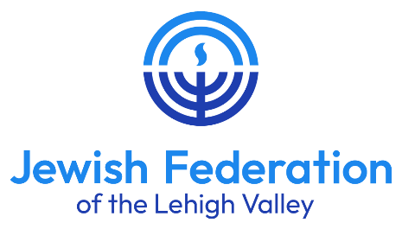
Send completed applications to:
Scholarship Committee
Jewish Federation of the Lehigh Valley
ATTN: Jeri Zimmerman
702 North 22nd Street
Allentown, PA 18104
610-821-8946 FAX
Jewish Teen Experience/Education incentive grant application
[NOTE: For need-based Jewish resident camp scholarships, please refer to
separate application form at www.jewishlehighvalley.org.
TEEN EXPERIENCE INCENTIVE GRANT APPLICATIONS ACCEPTED THROUGH MARCH 20, 2026

Name of Teen: |  |  |  |  |  |  |  | Date of Application:
Address:
Phone: |  |  |  |  | Email:
School: |  |  |  |  | Current (2025-26) Grade: |  |  |  |  |  |  | DOB:
Youth Group Membership(s): |  | No Yes:
Synagogue Membership(s): |  | No Yes:
Allentown JCC Member: |  | No Yes
I request consideration for a Jewish Federation Jewish Teen Experience Incentive Grant to participate in the following Program: (Please provide name, location, description, and dates for this program. Also, please indicate the name and address of the program’s sponsoring organization.)
What is the total cost, excluding transportation, for your participation in this program?
How much money are you and your family willing to contribute for this program?
How much are you requesting in scholarship for your participation in this program?
What other scholarships have you applied for and/or been awarded?
What are your goals for your participation in this program?

Briefly describe your Jewish educational background and involvement in the Jewish community:
Describe any activities or community service you plan on doing with the skills/knowledge that you gain in the program
(e.g. speaking to others about your program, how you might become more involved, doing community service, etc.):
Please describe any extenuating circumstances or financial hardships (use additional space if necessary):
Signatures:
Teen Scholarship Applicant |  |  | Signature of a Parent or Guardian
 |  |  | Parents’ Email, if different
 |  |  | **REQUIRED** [Grant awards will be sent to the Parents’ email]

General Information:
These scholarships are made possible by the Jewish Federation of the Lehigh Valley’s Annual Campaign. The scholarships are awarded to individuals and institutions for Jewish teen education experiences that will enrich the recipients, enhance the community, and increase the likelihood of future engagement within Jewish life. Scholarships may be requested for Jewish summer camps, Jewish youth group summer programs, Jewish youth group conventions, certain trips to Israel, etc.

- Only Jewish teens in grades 9-12, residing in the Lehigh Valley area, are eligible.
- The program may be located outside of the Lehigh Valley area. The program must be organized by a recognized organization and must be a teen/peer program. Adult or family trips do not qualify.
- Membership at an area synagogue, Jewish youth group, and/or the JCC is preferred, but not a requirement.
- Trips to Israel being funded by a Jewish Federation VISIT savings incentive program grant are not eligible.
- Limited funds are available. Every effort will be made to support participation. While this grant is not needs-based, where financial hardships exist, the situation should be articulated in separate communication to the Jewish Federation Director. All information will be treated confidentially.
- The maximum grant award, at this time, is $500 and may not exceed 50% of the cost of the program, excluding transportation. Actual award level will be determined by the funds available, the number of applicants, and the cost/length of the program.
- Recipients are encouraged to share their experiences and newly gained knowledge with the community through Hakol articles, educational workshops, and information discussions.
- Awarded funds will be disbursed directly to the sponsoring organization to the account benefit of the participating teen. Funds will not be sent to the teen or the teen’s family.
- Applications are on a rolling acceptance through March 20, 2026.

