
Chair Cindy Finestone
Treasurer/Secretary Irvin Skopp

Term Expiring, June 2020 | Term Expiring, June 2021 | Term Expiring June, 2022
Irvin Skopp | Cindy Finestone | Michael Greenberg
 | Charles Jalenak | Lee Harkavy
 | Scott Notowich | Eileen Posner
_________________________________________________________________________________________________
Chair Anthony Morrison
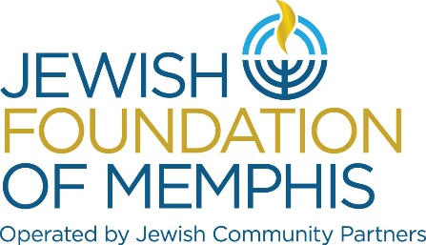
Treasurer/Secretary Irvin Skopp

Term Expiring, June 2020 | Term Expiring June, 2021 | Term Expiring June, 2022
Stanley Bilsky | Hal Fogelman | David Greenberg
Charles Jalenak | Terri Mendelson | Rudi Scheidt
Irvin Serenco | Anthony Morrison | Irvin Skopp
Jerry Sklar | Jason Salomon

Agency Appointees to JFOM Board (not elected): Julie Levy, Elaine Wagner Skopp, Dot Bilsky, Alla Lubin, Nina Blockman,
Judy Bookman, Sam Chafetz, Judy Royal, Wendy Rotter
__________________________________________________________________________________________________

Executive Committee
Chair JCP Ken Steinberg
Chair MJF Cindy Finestone
Chair JFOM Anthony Morrison
Treasurer/Secretary Irvin Skopp
Vice Chair FRD Scott Vogel
Vice Chair Community Impact Jimmy Ringel and Steve Libby
Vice Chair Israel and Overseas Scott Notowich
Vice Chair Young Adult Aviva Freiden
Counsel Michael Kaplan
Past Chair JCP Michael Greenberg
Past Chairs MJF & JFOM Ken Steinberg and Charles Jalenak
Chair Appointees Pace Cooper and Jason Salomon
Craig Weiss

Term Expiring June, 2020 | Term Expiring June, 2021 | Term Expiring June, 2022
Sam Chafetz | David Cooper | Lisa Barden
Bob Eiseman | Cindy Finestone | Dorit Boxer
Aviva Freiden | Mark Fogelman | Pace Cooper
Jonathan Frisch | Mimi Grossman | Hal Fogelman
Debbie Lazarov | Charles Jalenak | Michael Greenberg
Josh Lipman | Michael Kaplan | Jan Groveman
Alla Lubin | Steve Libby | Lee Harkavy
Hal Newburger | Scott Notowich | Gary Kaplan
Wendy Rotter | Ken Steinberg | Michelle Katz
Irvin Skopp |  | Sarah Lewis
Jason Salomon |  | Anthony Morrison
Andie Uiberall |  | Jimmy Ringel
Craig Weiss |  | Jill Shanker
 |  | Scott Vogel

