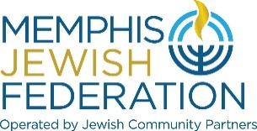
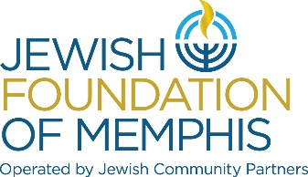
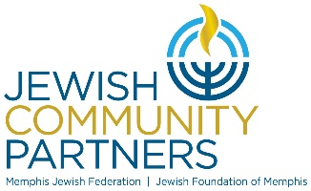
Board of Directors Board Meeting
June 7, 2022, 5:30 pm
MINUTES

On June 7, 2022, Jewish Community Partners, Memphis Jewish Federation and Jewish Foundation of Memphis held a Board Meeting to conduct its business via Zoom.us.

At 5:30 pm, Mr. Scott Vogel, chair of the Jewish Community Partners, called the meeting to order.

Jewish Community Partners Board of Trustees in Attendance
Herbert Gerson, Mark Gillenson, Lee Harkavy, Charles Jalenak, Michael Kaplan, Gary Kaplan, Marty Kelman, Jason Salomon, Irvin Skopp, Ken Steinberg, and Scott Vogel

Memphis Jewish Federation Board of Trustees in attendance
Cindy Finestone, Hal Fogelman, Jonathan Frisch, Jan Groveman, Lee Harkavy, Michelle Katz, Susanne Landau, Emily Lennon, Steve Libby, Alla Lubin, Scott Notowich, Eileen Posner, Shelley Robbins, Jill Shanker, Kimberlee Strome, Elissa Taub, Andie Uiberall, Keri Unowsky, Scott Vogel and Craig Weiss.

Jewish Foundation of Memphis Board of Trustees in Attendance
Dot Bilsky, Stanley Bilsky, Judy Bookman, Sam Chafetz, Pace Cooper, Rick Fogelman, David Greenberg, Paula Jacobson, Reed Landau, Ron Lazarov, Anthony Morrison, Judy Moss, Laura Paller, Wendy Rotter, Judy Royal, Jason Salomon Irvin Skopp, and Elkan Scheidt.

Jewish Community Partners Staff in Attendance
Sheri Gadberry, Judy Lansky, Laura Linder, Carrie Richardson, Larry Schaffer, Matt Timberlake, Sarah Vanderwalde, Tim Wheat, and Bluma Zuckerbrot-Finkelstein.

Budget Review and Approval
Jason Salomon, JCP Treasurer, reviewed the Jewish Foundation of Memphis 2022-2023 Proposed Budget. There is a $170k surplus which is broken down into $54k to be used towards the Foundation Strategic Plan and $116k will be held in reserve for operational needs. There are 2 open Foundation positions: Accounting Associate and Programming Associate. The Foundation budget will absorb 25% of the ATA process/policy audit.
Mr. Salomon reviewed the Memphis Jewish Federation 2022-2023 Proposed Budget. There is a $154k surplus from the FY20-21 budget that will be applied to the FY22-23 budget. The $40k surplus from this years budget will be applied to the FY 23-24 budget as per policy. There are 3 open Federation positions: Director of Leadership & Engagement, Campaign Associate and Director of Grants Technology. The Federation budget will absorb 75% of the ATA process/policy audit. The Security budget line has increased due to an anticipated loss of the SCN security grant, from 45k to 85k. The Federation budget will cover the Israel@75 programming instead of the Lemsky Endowment Fund.

Local Grants FY22-23 budget shows a total of $48k of unallocated funds. Local agencies like JCRS, NCSY and Plough Towers allocations increased this cycle. FJFS is not listed on the grants budget as the agency has an Endowment, United Way doubled gift and PPP money. Lee Harkavy wanted it noted that the largest grantee that we allocate funds to is Memphis Jewish Federation programs, $564k.
Laura Linder stated that the total budget is broken down into the following:
81.8% of funds goes to programming
3.49% of funds goes to Israel programming
7.56% of funds goes to Fundraising
7.15% of funds goes to Administration

With no other questions, Jason Salomon called for motion to approve the budgets. Lee Harkavy moved the Federation and Foundation FY2022-2023 Budgets be approved and Eileen Posner seconded the motion. The FY2022-2023 Federation Operational, Federation Local Grant Budget and Foundation Operational Budget were approved.

Lemsky Grants
Scott Notowich, VC Israel and Overseas, reviewed the Lemsky Fact Finding Mission trip to Israel. the group visited serval JAFI programs that we fund. The final grants meeting had to be postponed to meet June 15th and then recommendations will be presented to the board.

President’s Report
Laura Linder, JCP President and CEO, shared what her community concerns are for Memphis: meeting community needs, the next generation, aging donors, attitudes toward Israel and political issues. JCP personnel update in welcoming Judy Lansky , Director of Development and Phyllis Abraham, Operations Analyst. Upcoming events will be June 8 is the Lion of Judah Spring Reception and June 22 is the Annual Meeting.

The meeting was adjourned at 6:30 pm.

