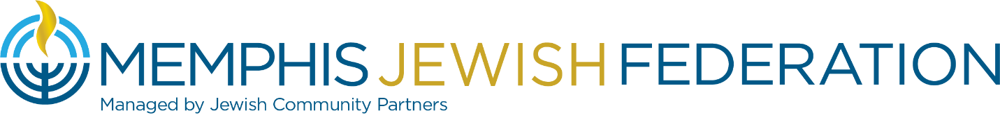
Board of Directors Board Meeting
March 28,2023 5:30 pm
MINUTES

On March 28, 2023, Memphis Jewish Federation Board of Directors held a Board Meeting to conduct its business in the MJCC Board Room.

At 5:30 pm, Cindy Finestone, MJF Chair, welcomed all to the meeting.

Memphis Jewish Federation Board of Trustees in Attendance
Cindy Finestone, Hal Fogelman, Aviva Freiden, Susanne Landau, Debbie B. Lazarov, Richard Lewis, Michael Kaplan, Michelle Katz, Steve Libby, Alla Lubin, Scott Notowich, Eileen Posner, Jill Shanker, Daniel Snyder, Elissa Taub, Andie Uiberall, and Keri Unowsky.

Jewish Community Partners Staff in Attendance
Sophie Bloch, Judy Lansky, Laura Linder, Carrie Richardson, and Bluma Zuckerbrot-Finkelstein.

Guests in Attendance
Asher Crouch, Tess Herzog, Amirah Bauder, Samuel Cross and Mandy Cassius.

Cindy Finestone, MJF Chair, called the meeting to order and called for approval of the February 21, 2023, Board Minutes. Alla Lubin moved that the minutes be approved, and Hal Fogelman seconded the motion. The February 21, 2023, Board Minutes were approved.

Impact
Sophie Bloch, Director of Hillel, introduced the 5 Rhodes Fellows in attendance: Asher, Tessa, Amir, Samuel Cross and Mandy. Each Fellow spoke of their positive experience with Hillel on the Rhodes campus.

Campaign Update
Steve Libby, VC FRD, reviewed the March 27th Campaign Update handout:
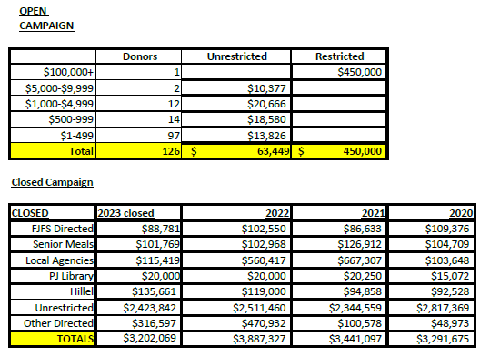

Actions Items
Cindy Finestone reviewed the following items:

Action 1: Signatory Authority*
This is an amended version of a corporate resolution that currently exists granting certain employees of Jewish Community Partners the authority to sign documents on behalf of Memphis Jewish Federation. This new version adds Bluma Zuckerbrot-Finkelstein, Executive Vice President and Chief Impact Officer and Laura Kaplan, Vice President of Finance and Operations as signatories. The new document also outlines what these specific JCP employees are authorized to sign and clarifies the process for situations that involve expense that falls outside of the current budget by denoting what additional approvals are necessary. Jill Shanker motioned that the resolution be passed with the following minor modifications:

For contracts or grants outside of the budget the following approvals are required:
- Up to $10,000 requires approval by the President or an Executive Vice President
- Between $10,000 and $20,000 requires approval of both Chair and Executive Director President/CEO

Michael Kaplan seconded. It was approved.

Action 2: Calculation of Annual Camp Scholarships Award
Because of the recent board approved change to the Jewish education funding model (October 2022) which replaced the formula-based grant for education (37% of local allocable pot) with base funding amounts for day and religious school students, the previous policy of awarding 12% of the total education pot toward need-based camp scholarships no longer applies. Therefore, the following policy is proposed:
Beginning with the 2023/2024 grants process, an amount equal to the prior five years average amount granted for need-based camp scholarships will be awarded from the unrestricted campaign for distribution to applicants by the anonymous camp scholarship committee (“committee”). Approximate grant award is $48,000. Should there be a year when there is an increase in the number of applicants, there is an increase in the cost of camp, or other hardships exist that would necessitate a need for additional grant dollars, the committee may request additional funds from the MJF Board of Directors.
Scott Notowich motioned, and Daniel Snyder seconded. Approved.

Action 3: Naming Rights for Hillel of Memphis*
The building name will remain the “Morris S. Fogelman Hillel of Memphis” so long as it is located at 3581 Midland Avenue Memphis, TN 38111; and whenever an event is to be hosted at 3581 Midland Avenue Memphis, TN 38111, or the Hillel location is mentioned in publication, it will be listed as the “Morris S. Fogelman Hillel of Memphis.” Steve Libby motioned, and Susanne Landau seconded. Approved.

Action 4: Calculation of Plough Foundation Endowment Campaign Gift for 2023
• 2023 campaign gift will be equal to 5% of the March 31, 2023, fund value.
• 2023 campaign payment will be equal to 5% of the September 30, 2023, fund value (per gift agreement).
• If the campaign payment is less than the campaign gift, the balance will be made up from the Federation’s Savings Account (Current value is approximately $1 million)
• If the campaign payment is more than the campaign gift, that amount will remain in the endowment fund.
Andie Uiberall motioned, and Eileen Posner seconded. Approved.

Needs Assessment Update
Mrs. Finestone introduced Susanne Landau, Needs Assessment chair, to give the board an update. On March 9th, all 3 boards were emailed a Needs Assessment Update email which reviewed the last board meeting’s breakout sessions results.

Israel Update
Scott Notowich, VC Israel and Overseas, reviewed the Jewish Organizations Welcome Suspension of Judicial Overhaul Legislation handout. Mr. Notowich reviewed the Hebrew Watchman’s article about Andy Groveman representing Memphis at a JFNA Israel Fly-In.

Community Relations Update
Bluma Zuckerbrot-Finkelstein, JCP CIO and MJF EVP, reported that Rachel Shankman, CRC Education Committee chair will be presenting Judaism 101 at FedEx. Margo Gruen hosted an event at her home where attendees brought a non-Jewish guest to begin to build relationships. Mrs. Finkelstein reported that this week we joined the fight to Stand Up to Jewish Hate, a campaign to raise awareness about antisemitism and mobilize all Americans to show support for the Jewish community as we address growing hatred and intolerance. We are asking everyone to post and share #🟦 on social media, using the blue square emoji on your phone, as a simple but powerful unifying symbol of solidarity. Together, we can educate and empower more Americans to join in the fight to #StandUpToJewishHate.
President’s Report
Laura Linder, JCP CEO & President, congratulated board member Kimberlee Strome for being named to the National Women’s Philanthropy Board. Mrs. Linder highlighted the launch of Lion Behind the Pin initiative and several communities from across the country have ordered boxes for their Lions of Judah. The exterior renovations at Hillel U of M campus are continuing and still on track.
Cindy Finetstone adjourned the meeting at 6:42 pm

