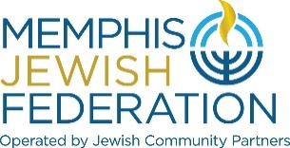
Memphis Jewish Federation Board of Directors Board Meeting
March 23, 2022, 5:30 pm
MINUTES

On March 23, 2022, Memphis Jewish Federation held a Board Meeting to conduct its business via Zoom.us.

At 5:30 pm, Mrs. Cindy Finestone, chair of the Memphis Jewish Federation of Directors, called the meeting to order.

Memphis Jewish Federation Board of Trustees in attendance
Bob Eiseman, Cindy Finestone, Hal Fogelman, Aviva Freiden, Jan Groveman, Lee Harkavy, Susanne Landau, Debbie H. Lazarov, Emily Lennon, Richard Lewis, Sarah Lewis, Steve Libby, Jaclyn Marshall, Scott Notowich, Eileen Posner, Jimmy Ringel, Shelley Robbins, Jill Shanker, Daniel Snyder, Kimberlee Strome, Elissa Taub, Andie Uiberall, Scott Vogel

Jewish Community Partners Staff in Attendance
Michael Barnett, Sophie Bloch, Sheri Gadberry, Steven Holman, Melinda Lejman, Laura Linder, Elyssa Pfeffer, Carrie Richardson, Lorraine Wolf and Bluma Zuckerbrot-Finkelstein.

Guests
Amirah Bauder, Sam Cross, Sophie Enda, Tess Herzog and Robbie Musicante

Mrs. Finestone called for approval of the March 3, 2022, Board Minutes. Eileen Posner moved to approve the minutes, and Jimmy Ringel seconded the motion. The March 3, 2022 Board Minutes were approved.

Speakers
Sophie Block, Director of Hillel, introduced the Rhodes College Jewish Community Fellows. Amirah Bauder, Sam Cross, Sophie Enda, Tess Herzog, and Robbie Musicante took turns speaking on how the fellowship enhances their college and Jewish life on campus.

Ethiopian Aliyah Funding
Scott Notowich, VC of Israel/ Overseas, reviewed the Jewish Agency for Israel’s effort to bring an additional 3,000 Ethiopian Jews to Israel and aid in their absorption into Israeli society. The Federation would grant $35,000 from Federation’s Lemsky Endowment Fund to Jewish Federations of North America, supporting the Jewish Agency for Israel effort. Steve Libby moved that the grant to JFNA be approved, and Jan Groveman seconded the motion. Ethiopian Aliyah Funding was approved.

Annual Campaign & Ukraine Update
Jimmy Ringel, FRD co-chair, review the campaign update document:
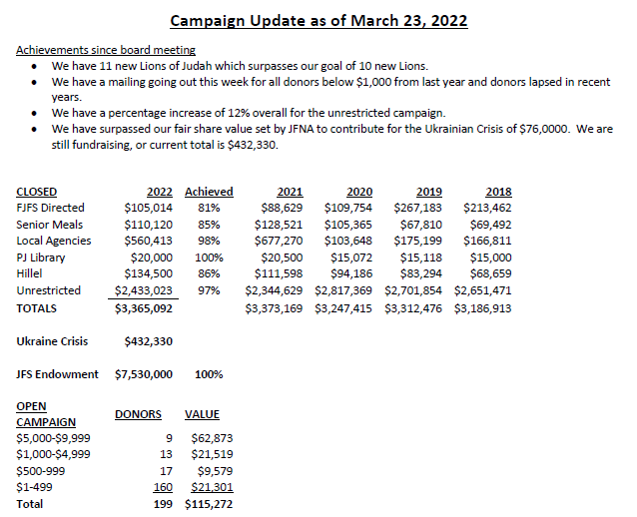

As of March 23, 2022, Federation and Foundation have raised $432,330 for the Crisis in Ukraine.
Security Update
Laura Linder, JCP President & CEO, reviewed the 30-60-90-day security plan. Amanda Braswell provided the updated graphic below and has a new PT admin Phyllis Abraham.
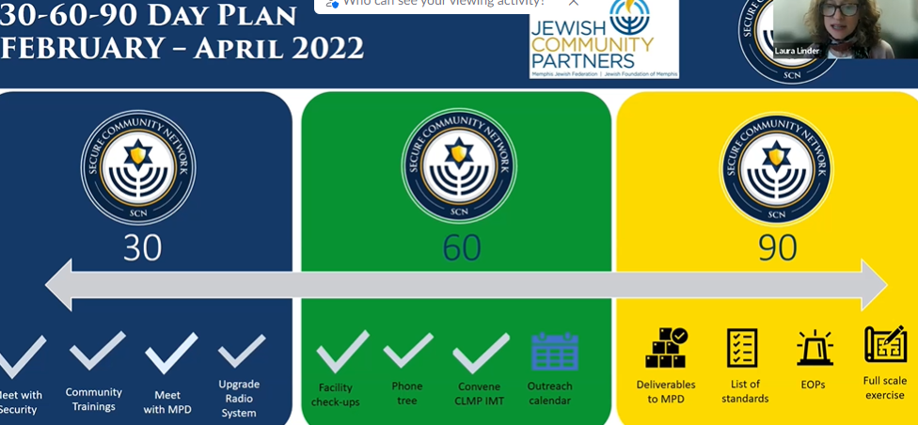
JFNA grant “Live Secure” will match $1 to every $2 raised for security.
Community Impact Update
Bluma Zuckerbrot-Finkelstein, JCP CIO, reviewed Community Relations progress and created three new task forces under the Senior Services Collaborative: Community-Wide Impact/Scorecard, Broadening the Reach of Senior Meals, and Affordable Assisted Living/Memory Care. They are beginning to recruit members for the new Community Relations Council. A new event program for high school seniors, “Confronting Antisemitism and Anti-Zionism on College Campuses,” will be held at Hillel with the Teen Professional Council.
President’s Report
Laura Linder, JCP President and CEO, shared that Mark Wender, past JCP COO, was the one to reach out to Rhodes College to start a Hillel chapter.
Federation and Foundation have received 200 gifts for the Crisis in Ukraine, and one such gift was from Sydney and Jack Shanker, who saved their change and donated it to Ukraine. Along with leadership briefings featuring Illana Kwartin, JAFI, and virtual Town Hall Briefings on Ukraine, JCP will roll out an initiative to collect medical supplies donations to send to an Israeli field hospital. Lastly, Jaclyn Marshall and Martin Klazmer, FedLed chairs, have been working on a Young Adult Israel Adventure from February 12-19, 2023.
The meeting was adjourned at 6:30 pm.

