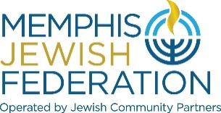
Memphis Jewish Federation Board of Directors Meeting
January 27, 2022 5:30 pm
MINUTES

On January 27, 2022, Memphis Jewish Federation, held a special Board Meeting to conduct its business via Zoom.us.

At 5:30 pm, Mrs. Cindy Finestone, chair of the Memphis Jewish Federation of Directors, called the meeting to order.

Memphis Jewish Federation Board of Trustees in attendance
Cindy Finestone, Hal Fogelman, Aviva Freiden, Jonathan Frisch, Michael Greenberg, Jan Groveman, Lee Harkavy, Michelle Katz, Martin Klazmer, Susanne Landau, Debbie H. Lazarov, Emily Lennon, Sarah Lewis, Steve Libby, Alla Lubin, Jaclyn Marshall, Scott Notowich, Eileen Posner, Jimmy Ringel, Shelley Robbins, Jill Shanker, Daniel Snyder, Kimberlee Strome, Elissa Taub, Andie Uiberall, Keri Unowsky and Scott Vogel.

Jewish Community Partners Staff in Attendance
Michael Barnett, Melinda Lejman, Laura Linder, Elyssa Pfeffer, Carrie Richardson, Tim Wheat and Bluma Zuckerbrot-Finkelstein.

Mrs. Finestone called for approval of the November 17, 2021 and December 15, 2021 Board Minutes with the correction of attendance. Andie Uiberall moved that the minutes be approved, and Michelle Katz seconded the motion. The November 17, 2021 and December 15, 2021 Board Minutes were approved.
Mrs. Finestone reviewed the proclamation from the office of Governor Lee regarding Holocaust Remembrance Day
C. Finestone lead the board through an icebreaker exercise utilizing Mentimeter/Word Cloud:
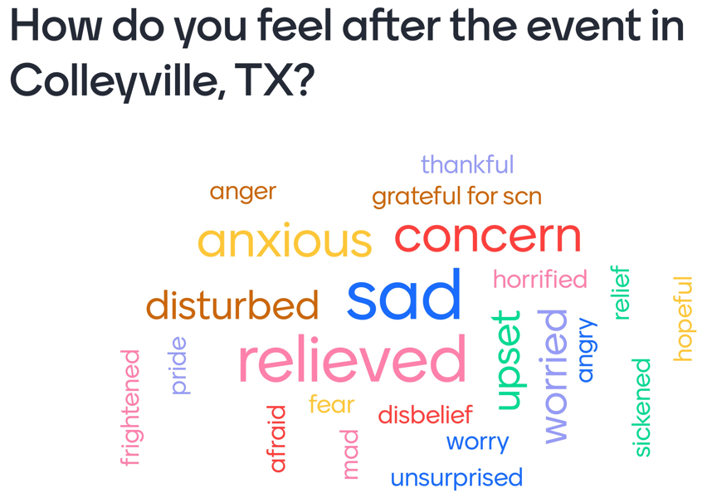

Security
Cindy Finestone shared dates/times of the Community Briefing Encore Showings, BeAware and CATT trainings. Amanda Braswell, SCN/JCP Regional Security Director, shared with the board our 90 Day Plan.
- 30 day- meet with MPD, meet with security, community training
- 60 day- facility checks, phone tree creation, outreach initiative and calendar
- 90 day- deliverables to MPD, list of standards, EOPs and full scale exercise

Community Relations & Shine a Light

Janis Finan, chair of CRC, reviewed the new mission statement again and reported the Decision Tree will be created to show how information will go from the CRC committee out to the community at the next meeting in mid Februrary. The current CRC committee members are Rachel Shankman, Jeri Moskowitz, Jill Notowich, Janis Finan, Alex Saharovich, Jason Goldstein, Mary Trotz and Michael Greenberg.
Jill Notowich reported on the Shine a Light on Antisemtism initiative that was made possible by a JFNA micro grant. 8 videos were released over Hannakah, ongoing initiative is still well received and big thank you to Jason Goldstein for speaking at MUS.
Bluma Zuckerbrot-Finkelstein shared a statement of solidarity from the Greater Memphis United Chinese American Community Association.
Cindy Finestone updated the board that the Nashville lobbyists are still seeking legislative funding to assist us and ask if the board have any connections to anyone that can help.

Campaign Update
Jimmy Ringel, FRD co-chair, reviewed the campaign to date and stated we are approximately $30,000 away from completing funding Senior Meals. Mr. Ringel asked the board to sign up for Call Nights. One of the campaign goals is to identify 20-25 new prospects.

New Needs Assessment Iniative
Susanne Landau, CRC chair, reviewed the new Community Relations mission statement:
Mission: The Community Relations arm of Memphis Jewish Federation seeks to advance the values, interests and priorities of the Memphis Jewish community through partnerships and collaborations within the Jewish and greater Memphis community.
Core Values:
- We are inspired and guided by Jewish values;
- We seek to foster Jewish unity and consensus;
- We seek civil discourse and mutual respect with those with whom we disagree;
- We support a secure and thriving State of Israel and the well-being of its people.
Strategic Priorities:
- Convene, educate, mobilize and unite the Jewish community around combatting Antisemitism and anti-Israel bias, and other issues facing our Jewish community, global Jewry and Israel;
- Engage in advocacy on issues related to Jews and Israel in local, state, national & international arenas;
- Build relationships and partnerships with other ethnic, faith-based and civic groups around issues impacting the Jewish and greater Memphis community;
- Serve as a resource on Jews, Judaism and Israel to the Jewish and greater Memphis community.

--Approved by the CRC Working Group on Policies &Protocols, November 2021
Mrs. Landau asked the board “What are the top 2-3 types of community data you want to know?” (answers following minutes) and then reviewed the newly established task forces under CRC.
- Teen Wellness ()
- Millennial Engagement with Israel (Michael Alpert)
- Increasing Capacity if Day schools & ECC (Lisa Frisch)
- JFNA mini study (Josh Sanderson)
CRC Committee members are Michael Alpert, Josh Sanderson, Lisa Frisch, Andie Uiberall, Josh Sanderson, Morris Landau, Emily Lennon, Joelle Rogin, Susan Lindy and Jay Cohen.

Young Adult Engagement
Jaclyn Marshall, YA Engagment co-chair, reported there were 17 attend the Network Breakfast in January. The planning for the YA Gala is coming along and the date is set for May 19th.

Grant Process
Sarah Lewis, Community Grants co-chair, reported that the new cycle of grants opens February 1st on the grants portal and the grants committee has been confirmed at 10 members.

President’s Report
Laura Linder, JCP President & CEO, thanked LOJ chair, YA chair and Regional Security Director for jobs well done and amazing leadership. Breakdown of Security costs are 77k provided by SCN, 25k provided by Agencies and 45k provided by our annual campaign. The FJFS Endowment is at 7.2 million.

The meeting was adjourned at 6:27 pm.

