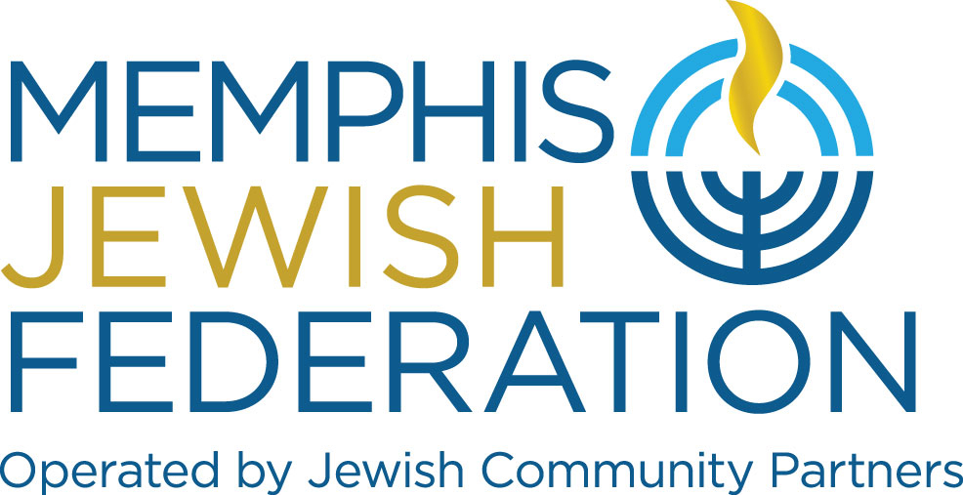

Memphis Jewish Federation
Board of Directors Code of Ethics and Confidentiality Agreement

In order to encourage and foster open and candid discussion at its meetings, the Board of Directors of the Memphis Jewish Federation believes confidentiality must be maintained. Therefore, it is the policy of the Board of Directors of the Memphis Jewish Federation that each director and staff member shall keep confidential any and all information relating to discussions at its meetings unless compelled by legal process to disclose such information, or as otherwise agreed by the Board.

Board members acknowledge that any violation of this policy could hinder candid discussion and Board deliberations. Therefore, any Board member who violates this policy shall be subject to termination of his/her Board position by majority vote of the current serving members of the Board of Directors.

In order to ensure compliance with applicable laws and to protect Memphis Jewish Federation, its members, officers, directors, staff, and committee members from potential legal problems regarding conflicts of interest and violation of fiduciary obligations, Memphis Jewish Federation endorses and adopts the following statement of policy:

- Duty of Loyalty

Among the fiduciary obligations of an officer, director, staff member, or committee member of a non-profit corporation is a duty of loyalty to the non-profit corporation. This includes supporting, and not opposing directly or indirectly or taking any other stance against, the policies and positions duly adopted by Memphis Jewish Federation’ Board of Directors. As representatives of Memphis Jewish Federation, officers, directors, staff, and committee members are obligated to maintain this duty of loyalty in all manner of activities during their terms of office. This duty of loyalty is not intended to, nor should it discourage debate within Board or committee meetings. Such debate is encouraged and is part of the individual's responsibility in the deliberation process.

- Confidentiality of Board Discussions and Board Documents

In order to encourage and foster open and candid discussion at its meetings, the Board of Directors of Memphis Jewish Federation believes confidentiality must be maintained. Therefore, it is the policy of the Board of Directors of Memphis Jewish Federation that each director and staff member shall keep confidential any and all information relating to discussions at its meetings, including any and all materials, e.g., correspondence, reports, etc., unless compelled by legal process to disclose such information, or as otherwise agreed by the Board. Disclosing or distributing any information concerning the discussion of such items during the Board meeting is prohibited.

For the purpose of this Agreement, confidential information shall not include information that is:
- Readily available to the public in the same or an equally useable form as that maintained by Memphis Jewish Federation;
- Has been lawfully received from an independent third party without any restriction and without any obligation of confidentiality; or
- Has been independently developed without access to or knowledge or use of the Confidential Information.

If a board member inadvertently receives a confidential document(s), the board member shall immediately return the confidential document(s) to Memphis Jewish Federation. Anything that cannot be returned shall be completely destroyed, including but not limited to, deleting any copies from computers, deleting emails that refer to confidential document(s), and any reproduction thereof.

- Conflicts of Interest

Another fiduciary obligation of a non-profit corporation officer, director, staff, and committee member is to avoid "conflicts of interest". A "conflict of interest" is generally defined as a
transaction in which, because the individual is, either directly or indirectly, a party to the transaction or possible beneficiary of the transaction, there is or may be a conflict between the
individual's fiduciary obligations to the non-profit corporation and the individual's personal or business interests. To avoid potential conflict of interest problems, the Jewish Foundation of Memphis implements the following procedures:

- In any transaction involving Memphis Jewish Federation and a Memphis Jewish Federation officer, director, staff, or committee member, and any corporation, partnership or other entity in which an individual is an officer, director, staff, or committee member has or expects or intends to have a financial or other beneficial interest, such individual, prior to any discussion or decision concerning the transaction, shall fully disclose to Memphis Jewish Federation Board or to the appropriate committee considering the transaction, the material facts of the transaction and the individual's interest or relationship.

- Upon such disclosure, the individual shall take no further part in the meeting during which time the proposal is considered and voted upon.

- After receiving such disclosure, prior to approving the transaction, the board or committee must conclude that the transaction is “fair to the Jewish Foundation of Memphis” and must approve the transaction without the participation or the vote of the interested individual.

- The interested individual's presence at the meeting may be counted in determining whether a quorum of the Board or committee is present, but that individual shall not vote on the transaction.

COMMUNITY INVOLVEMENT

I or my spouse have/has served on a governance or leadership body of, or have/has been employed by, the following agencies or organizations within the Memphis Jewish Community during the last three years:

FINANCIAL INVOLVEMENT
I or my spouse have/has a financial or ownership interest in or am/is employed by the following companies or firms that do, have done, or may be highly likely in the next two years to do business with the Memphis Jewish Community.

RELATIONSHIP WITH OTHER BOARD MEMBERS (FAMILY MEMBERS/SPOUSES)

- Fiduciary Obligations as to the Jewish Foundation of Memphis Opportunities

Another fiduciary obligation prohibits an officer or director of a non-profit corporation from seizing a "corporate opportunity" for his or her company's benefit or his or her personal benefit.
This means that such an individual may not take advantage of a business opportunity in which the officer or director knows Memphis Jewish Federation has a genuine interest and where such an Association opportunity would be consistent with Memphis Jewish Federation’ purposes, mission and goals as a non-profit corporation. Further, if the officer or director becomes aware of such an opportunity, he or she is obliged to so inform Memphis Jewish Federation and allow Memphis Jewish Federation to act first.

- Participation in Deliberations and Actions

In any case in which there is a question of loyalty, conflict of interest, or corporate opportunity raised, the officer or director shall not participate in the meeting for the entire time the matter is discussed and voted upon.

I have read and understand the above expectations for board members of Memphis Jewish Federation and agree to abide by this Code of Ethics and Confidentiality Policy.

_________________________________________ _ _________________
Board member signature Date

Printed name

