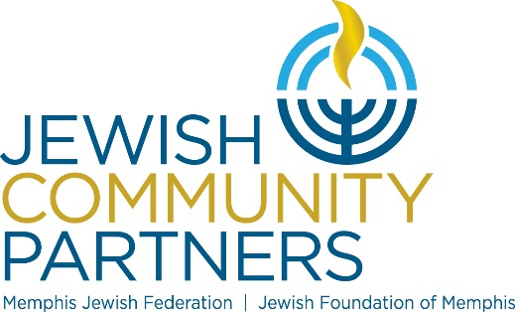
Jewish Community Partners Governance Calendar 2020/2021

 | JCP Executive Committee  @ 5:30 p.m. | JCP & Federation Board of Directors  @ 5:30 p.m. | Foundation Board of Directors  @ 5:30 p.m.
August 18, 2020 |  |  4:30pm | 4:30 pm
August 26, 2020 | 5:00pm
September 23, 2020 |  | FJFS
October 13, 2020
November 4, 2020
December 22, 2020
January 13, 2021
February 2, 2021
February 24, 2021
March 9, 2021
March 31, 2021
April 20, 2021
May 12, 2021
June 15, 2021
Annual Meeting

