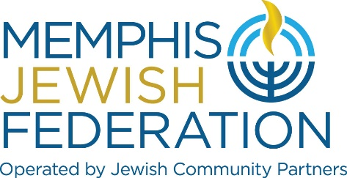

BOARD EXPECTATIONS
Members of the Board of Directors are well-respected leaders of the Memphis Jewish community who are viewed as global thinkers with the best interests of the entire Jewish community at heart. They are committed to building an organization that inspires community collaboration in order to sustain a vibrant Jewish community in Memphis, in Israel and throughout the world.

Board members are expected to serve as ambassadors of the Memphis Jewish community at all times providing support in the following ways:

- Serving as ambassadors and representing the Federation at our funded programs; and, when appropriate, speaking about how the program was made possible by generous Federation and/or Foundation donors.
- The Board is responsible for the fiscal health of the parent organization and its related entities therefore, each Board member will undertake to understand and review the budget and financial statements.

- Board members are expected to actively promote all levels of philanthropy through annual giving, endowment giving, legacy giving, supplemental/designated giving and emergency and special campaigns with the goal of building and sustaining a vibrant local and worldwide Jewish community.

- Board members are expected to make a capacity unrestricted annual commitment to MJF annual community campaign (suggested minimum $1800 for board members; $5,000 for executive committee members; $10,000 for chair) and be current in their payments. They are also expected to make endowment a priority in their tzedakah/charitable giving and to contribute what is for them a capacity gift, either current or deferred, to the Memphis Jewish organizations most important to them and to their families.
(Board members that are under 45 years old are expected to make capacity gift)

- Board members will actively engage in advocating with friends and colleagues the importance of philanthropy including annual giving, endowment and legacy. This shall include soliciting gifts for MJFs annual community campaign, taking an active role in promoting endowment/legacy initiatives and in individual and group conversations/announcements.

- Board members are expected to make their best effort to attend events including: board meetings, annual meeting, educational events, campaign events, etc.

- Board members are expected to operate in accordance with the by-laws of the parent organization and related entities and shall publicly support all decisions agreed to by the Board.

- Board members are expected to make their best effort to attend at least ¾ of all Board meetings each year.

- Board members are expected to participate as a fully engaged member/chair of at least one board committee.

- Board members are asked to sign a conflict of interest and disclosure forms at the meeting of the board immediately following the annual meeting.

- Board members should respect the confidentiality of Board discussions and not disclose confidential Board matters to others.

- Board members shall make best effort to visit Israel during his/her term of office and/or participate in at least one national conference (GA, Lion of Judah Conference, Investment Institute, etc.)

I have read and I understand the Expectations for Board Memberships.

Signed:

____________________________________________________ _____________________
Board Member Name Date

