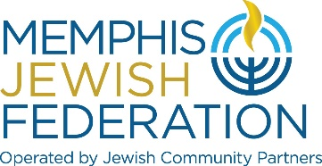

Executive Committee Meeting
May 25, 2022 | 5:30 p.m.
Via Zoom
Agenda

- Budget and Grants Presentation * Tim Wheat, Sarah Lewis, Scott Notowich

- Update on Needs Assessment and Bluma Zuckerbrot-Finkelstein
Community Relations

Upcoming Dates
June 2 – Budget Review 4pm https://us02web.zoom.us/j/81764040721
June 3 – Budget Review 12pm https://us02web.zoom.us/j/84048495056
June 7 – Final Board Meeting 5pm Foundation / 5:30pm JCP, Federation & Foundation
June 8 – Lion of Judah Spring Reception 11:30am
June 22 – Annual Meeting 7pm

*Attachment

