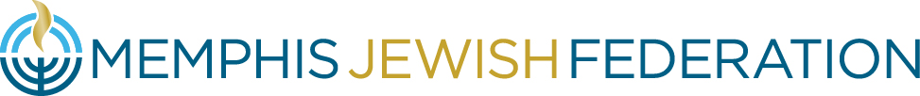

Federation Board of Directors Meeting
September 30, 2021 | 6:00 p.m.

- Welcome Cindy Finestone
  - Approval of Minutes*
  - Welcome of New Board Members
  - Icebreaker
  - Update on Progress toward Board-Approved Priorities
- Finance Report Jason Salomon
  - Budget Recommendation for Approval*
- Telling the Federation Story Cindy Finestone
  - My “Elevator Pitch” Keri Unowsky & Jill Shanker
  - Breakout Room Discussions
- Campaign Launch Jimmy Ringel & Jonathan Frisch
  - Campaign Donor Trends Elyssa Pfeffer
  - Campaign Plan
  - Board Expectations & Next Steps
- President’s Report Laura Linder
- Impact Story Bluma Zuckerbrot-Finkelstein
- Next Steps Cindy Finestone
- Adjournment Cindy Finestone

Upcoming Events
- October 1st Pickleball Tournament benefitting the Wendy and Avron B. Fogelman Jewish Family Service. Register here: https://www.jccmemphis.org/jfs/pickleball-palooza/
- October 3rd 1pm Virtual GA , Please register at https://generalassembly.org/
- October 5th 7pm Noa Tishby: A Guide to Israel – Jewish Federation of Nashville & Middle TN REGISTER HERE
- JDC Speaker Series
    - October 7th 11am The Incredible Story of Jews in India/China REGISTER HERE
    - October 14th 11am The Incredible Story of Jews in Morocco/Turkey REGISTER HERE
    - October 21st 11am Jewish Values at the Heart: JDC’s Disaster Response REGISTER HERE

Attachments *

