We are pleased to announce the FIRST recipients of the 2024 IGNITE! Jewish Rochester Community Impact Grants. The purpose of this grant funding is to empower and inspire new initiatives, spark collaborations, propel innovative programs and support and nourish a strong Jewish Rochester. IGNITE! Grants are truly a community effort – sourced from funds raised from the Rochester Jewish Community through donors generous contributions to the Jewish Federation’s Annual Campaign and conceptualized by our local organizations serving the Rochester Jewish Community.

IMPACT GRANTS - $25,000 EACH

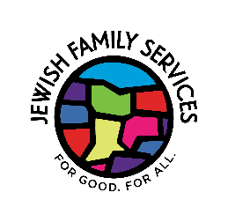
Expanded Youth Mental Health Services awarded to Jewish Family Services.

The Community Impact Grant will facilitate Jewish Family Services’ expansion of youth mental health services in the Jewish community by broadening accessibility to provide in-person services at synagogues, day schools, and childcare centers.

Collaborative Teen Engagement Program awarded to Temple Beth El.

Community Impact Grant funding will allow Temple Beth El, Temple B’rith Kodesh and Temple Sinai to expand their collaboration around teen engagement programming launched last year to include two additional age groups, 4th and 5th graders and middle schoolers, with the goal of bringing together Jewish students from all three synagogues for Jewish programming.

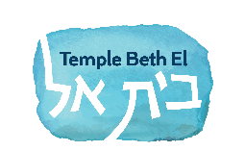

College Student Trip to Washington, D.C. awarded to Hillel of the University of Rochester.

Hillel of the University of Rochester will launch a Jewish identity and engagement trip to Washington, D.C. for college students (including, visiting the United States Holocaust Memorial Museum, the Capitol, monuments, Sixth & I Synagogue, meeting with our representatives) to reflect on what it means to be an American Jew - past, present, and future, to inspire students, increase Jewish pride, engagement and activism. Students participating in Rochester area college Hillel’s will be eligible to apply.



Community Holocaust Database and Cemetery Map awarded to the Holocaust Committee of the Friends of Mt. Hope Cemetery.

The Holocaust Committee of the Friends of Mt. Hope Cemetery will use the Community Impact funding to create one, comprehensive, community-wide database of all Rochester Holocaust survivors – that builds on and connects the work that has already been done at multiple organizations and includes burial locations, stories and ultimately digital maps of Holocaust survivors' gravesites to be used as an educational tool.

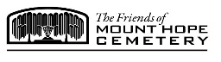

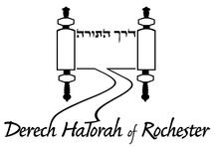
“Grow Rochester” Tuition Matching Fund awarded to Derech Hatorah.

A matching fund will be created, held at the Jewish Federation of Greater Rochester, using Community Impact Grant funds, to incentivize Jewish day school families to make donations supporting school tuition that will be matched dollar-for-dollar by the Federation, providing Jewish day schools with a 1-1 match and donors a tax benefit.

MICRO GRANTS - $2,500 EACH
Mothers and Babies awarded to Jewish Family Services (and Leora Rozin).

Jewish Family Services will launch an evidence-based postpartum depression prevention and stress management curriculum for mothers with babies up to one-year-old that also promotes Jewish values and personal connections.

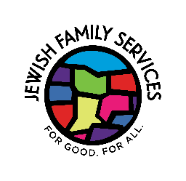
Jewish Pride Event to Combat Antisemitism awarded to ROC Against Antisemitism.

ROC Against Antisemitism will host a culturally and socially relevant program embodying Jewish pride via entertainment (comedian, musician or thought leader) while addressing the realities of modern antisemitism with a post-program discussion.

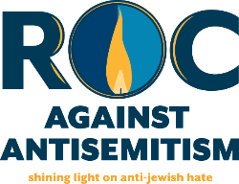

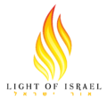
Eruv Maintenance and Repair awarded to Light of Israel .

Micro Grant funding will support repairs to the eruv infrastructure, including professional inspection, necessary replacements, and continued upkeep to maintain the integrity of the eruv serving the Orthodox community.

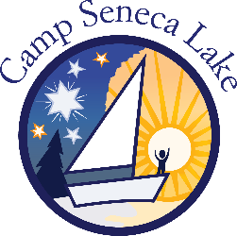
Alumni Shabbat Weekend awarded to Camp Seneca Lake, a program of the Louis S. Wolk JCC of Greater Rochester.

Camp Seneca Lake will host an inaugural Alumni Shabbat Weekend for young alumni this fall. Micro Grant funding will be used to reignite alumni ruach (spirit) at the program by encouraging increased Jewish engagement. The program will include a Kabbalat Shabbat t'filah, traditional Shabbat dinner and participants will receive a customized piece of Judaica to encourage Jewish practice at home.

Exploratory Committee for a Parenting Center awarded to Jewish Family Services (and Leora Rozin).

Jewish Family Services will use the Micro Grant fund to convene an Exploratory Committee to consider a collaborative and accessible Parenting Center in Rochester and wellness center, with a variety of offerings including, but not limited to, educational groups for parents/caregivers.

Compost Program awarded to Camp Seneca Lake, a program of the Louis S. Wolk JCC of Greater Rochester.

In line with the Jewish responsibility of l'vadah ul'shamrah, "to till and to tend" (the Earth), Camp Seneca Lake will use the Micro Grant fund to invest in a new compost system to minimize the camp’s carbon footprint, educate campers on how Judaism relates to the environment and our obligation as Jews to care for the environment.

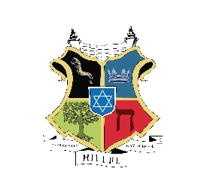
Portable Green House awarded to Hillel Community Day School.

To build upon their gardening program, Hillel Community Day School will use Micro Grant funding to purchase a portable greenhouse with the goal of the school garden generating 25% of the produce used for school lunches in addition to enabling students to grow vegetables in the winter.

