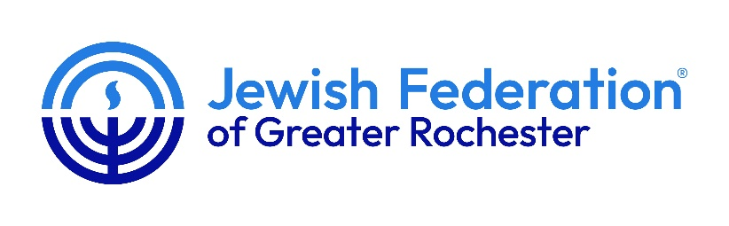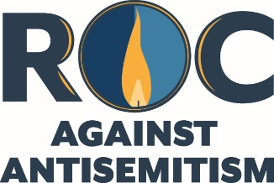

BLUE LIGHT PROJECT 2024

The Blue Light Project calls on people and businesses to take action and stand by their Jewish neighbors in the fight against the startling and unsettling increase in Jew hatred, around the world, we have seen nationally and right here in Rochester.

The purpose of the Blue Light Project is to show solidarity and support for the Jewish community by shining a visible blue light at their home or place of business, beginning on December 1, 2024 and continuing through the end of Hanukkah.

Participants in the 2024 Blue Light Project replace a regular lightbulb with a blue light in an outdoor lighting fixture (or in an indoor lighting fixture or window that can be seen from outside). The purposes of the blue light includes:
- Reminding people that antisemitism continues to be at its highest levels since the Holocaust Sparking conversations among friends and neighbors
- Fostering understanding and compassion for Jewish community members
- Promoting education and awareness of anti-Jewish hate and helping achieve the goal of everyone in our community being able to live a peaceful and secure life

Where do I get my blue lightbulb(s)?
Anyone may participate in The 2024 Blue Light Project. Free light bulbs and lights can be picked up at the following locations:
- The front desk of the Louis S. Wolk Jewish Community Center,1200 Edgewood Avenue anytime during regular JCC business hours
- Hadlock ACE Hardware, 3400 Monroe Avenue anytime during regular business hours. Supplies of free blue light bulbs are limited so we encourage community members to act fast.
- Lights are also available for self-purchase at Amazon.com (just search for “blue light bulbs” or “solar powered blue walkway light”) and at many other hardware or lighting stores (participants can order or purchase blue light bulbs from anywhere they choose). Please also consider purchasing a multipack and donating the extras to family, friends and neighbors so they can also shine a light against antisemitism).

We invite you to look for buildings downtown and throughout Monroe County lighted blue and take a picture and send it to us at info@jewishrochester.org.

The Blue Light Project is an independent project and is not affiliated with any other organization, political cause or social movement or effort.

