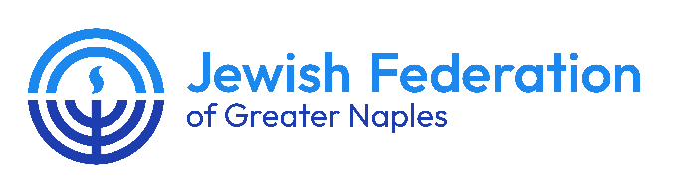

FGCU MENTORSHIP PROGRAM
The JFGN FGCU Mentorship Program is a selective initiative that pairs college juniors, seniors and graduate students with participating community members based on shared professional interests. For consideration, please complete the below application and submit to Alan Scher Zagier, Jewish Community Relations Council director, no later than 5 p.m. on Wednesday, Sept. 30, 2026.

Name _______________________________________________________

Address _____________________________________________________

Email _______________________________________________________

Cell Phone ___________________________________________________

Years of college completed _______________________________

Major__________________________________________________________________________________________

LinkedIn profile: ____________________________________________________________________________

Campus involvement (e.g., student clubs, organizations) __________________________________________________________________________________________________________________________________________________________________________________________________________

Leadership experience:_______________________________________________________________________________ ___________________________________________________________________________________________________________________________________________________________________________________________________________________________________________________________________________________________________________

Social media links: (Incl. Facebook, Twitter, Instagram, TikTok, YouTube) __________________________________________________________________________________________________________________________________________________________________________________________________________

Why do you want to participate in the JFGN FGCU Mentorship Program?
Click or tap here to enter text.=

What are your career/professional goals?
Click or tap here to enter text.

Describe your current, previous, and future involvement with Jewish educational, civic, and communal organizations, if any, including on campus as well as in your home community:
Click or tap here to enter text.

Identify an impactful adult mentor whom you have effectively worked with, such as a coach, teacher, rabbi, tutor, whether through a formal program or informally. What made this individual an effective mentor? What could they have done better?
Click or tap here to enter text.

Do you have access to transportation to meet in Naples as needed? Y/N: _____________________________
Please include a copy of your resume with this application.
Time Commitment/Participation Agreement
The program will run from October 2026 through April 2027, with participants encouraged to meet monthly. The first session will be an in-person, group gathering at the Nina Iser Jewish Cultural Center, 4720 Pine Ridge Road, Naples FL 34119, on Tuesday, Oct. 27, 6:30-8 p.m.
The remaining sessions will be scheduled directly with your mentor and can be held virtually, by mutual agreement.
I have read and understand the program expectations and agree to abide by those requirements:

Applicant Signature: Date completed:

