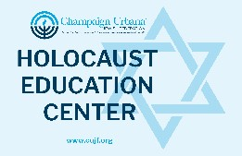


Dear Educator,

Thank you for taking the time to examine just a few of the many volumes we have available (free of charge) for use in your classroom, as you plan and deliver your Holocaust units.

The Holocaust Curriculum Trunk Project
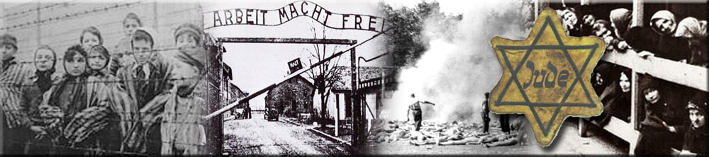
EXTENSIVE CLASSROOM MATERIALS – CUSTOMIZED FOR YOUR NEEDS!
- Free loan of classroom materials for teachers to plan, prepare, and deliver Holocaust education units.
- Guidance is available to create units and to address the many difficult topics present.
- Speakers may come to your classes to share their own or family members’ experiences.

- Teacher reference materials
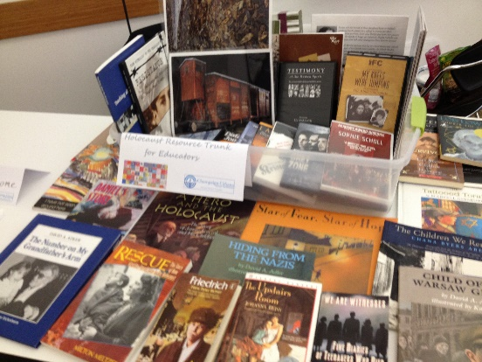
- Non-fiction student reference books
- Entire curriculum units with lesson plans and reproducible activities
- Classroom sets of classic and contemporary young adolescent novels based on the Holocaust
- Sets of children’s picture books.
- Poetry
- Professionally-designed plays for classroom use
- DVD’s and videos of Hollywood films and documentaries
- Posters maps, photographs, and timelines
- Jackdaw Kits (simulated primary source documents from the Holocaust)
PLEASE CONTACT: Brian B. Kahn briankah@uis.edu OR Robert Lehmann (lehmannb@gowestville.org)

Please also visit our website at: https://cujf.org/programs-and-services/holocaust-education-center

