24 Books for Teaching the Holocaust
A curated selection of powerful fiction and nonfiction books to help teach students in grades 1–12 about the Holocaust.
Grades
1 - 12
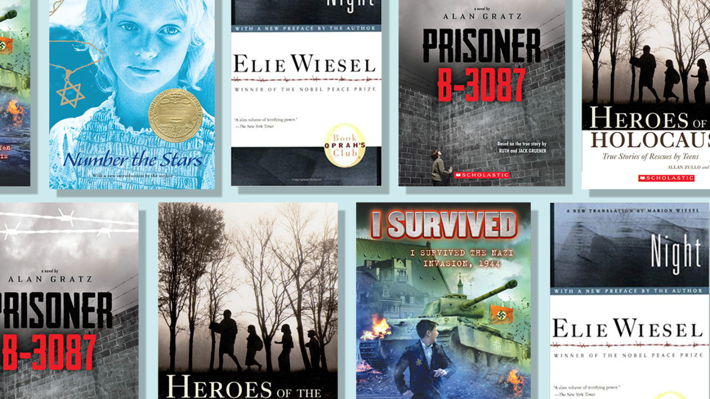
One of the most unimaginable tragedies of our time, the Holocaust can be a difficult subject to both teach and discuss. The 24 carefully curated books on this list can be used in a variety of ways to help students understand both the history and the cultural significance of this grave time period in human history. This list includes gripping first-person accounts from historical figures like Anne Frank and Elie Wiesel; moving stories of heroic rescues from both adult and children survivors; and award-winning, bestselling Holocaust fiction like Lois Lowry's Number the Stars and Marcus Zusak's The Book Thief. This collection is a essential resource for any classroom library.
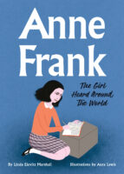
HARDCOVER BOOK

Anne Frank: The Girl Heard Around The World

Grades 1 - 3
Gorgeous prose and striking art deliver Anne's ever-relevant story with poignancy and grace, while robust back matter—including biographical information, an author's note, and a timeline—makes this the perfect book for history curriculums.
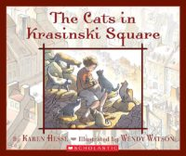
PAPERBACK BOOK

The Cats in Krasinski Square

Grades 3 - 5
A young Jewish girl and her sister face the challenges of growing up in Poland during World War II.
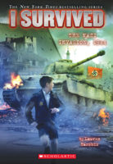
PAPERBACK BOOK

I Survived the Nazi Invasion, 1944 (#9)

Grades 4 - 6
In one of the darkest periods in history, one boy struggles to survive...
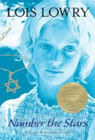
PAPERBACK BOOK

Number the Stars

Grades 5 - 6
As German troops begin their campaign to "relocate" all the Jews of Denmark, 10-year-old Annemarie Johansen's family takes in Annemarie's best friend, Ellen Rosen, and conceals her by pretending she's part of the family.
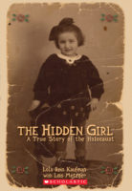
PAPERBACK BOOK

The Hidden Girl

Grades 5 - 7
When her mother is killed by the Gestapo, a Jewish girl named Lola is sent into hiding.
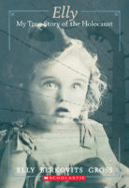
PAPERBACK BOOK

Elly

Grades 5 - 7
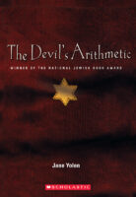
PAPERBACK BOOK

The Devil's Arithmetic

Grades 6 - 8
Hannah is tired of hearing about the Nazis during the Holocaust, but when she opens the door for Elijah at the Passover Seder, she is transported in time to 1940s Poland, where she is captured and put in a death camp.
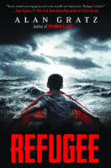
PAPERBACK BOOK

Refugee

Grades 6 - 9
A tour de force from acclaimed author Alan Gratz, this timely and powerful novel tells the story of three different children seeking refuge.
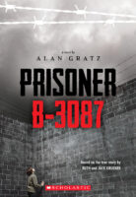
PAPERBACK BOOK

Prisoner B-3087

Grades 6 - 12
Ten concentration camps. Ten different places where you are starved, tortured, and worked mercilessly. It's something no one could imagine surviving. But it is what Yanek Gruener has to face.
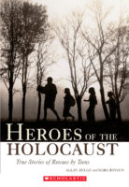
PAPERBACK BOOK

Heroes of the Holocaust

Grades 7
Maria Andzelm was a Catholic teenager whose family took in two Jewish men in Nazi-occupied Poland and hid them under their barn floor. Maria's stirring story is one of five featured in this important book of young people putting their lives on the line for others.
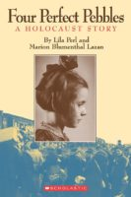
PAPERBACK BOOK

Four Perfect Pebbles

Grades 7 - 12
Following Hitler's rise to power, the Blumenthal family was trapped in Nazi Germany and, for over six years, was forced to live in refugee, transit, and prison camps. Their true story is one of horror and hardship, but also one of courage, hope, and the will to survive.
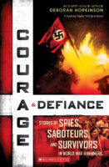
PAPERBACK BOOK

Courage & Defiance

Grades 8 - 11
Critically acclaimed Sibert Honor author Deborah Hopkinson brings to bold life the remarkable story of the Danish resistance and rescue of over 7,000 Jews during World War II.
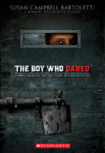
PAPERBACK BOOK

The Boy Who Dared

Grades 9 - 11
Author Susan Campbell Bartoletti has taken one episode from her Newbery Honor Book, Hitler Youth, and fleshed it out into a thought-provoking novel.
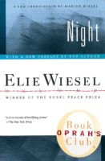
PAPERBACK BOOK

Night

Grades 9 - 12
A terrifying account of the Nazi death-camp horror that turns a young Jewish boy into an agonized witness to the death of his family, his innocence, and his god.
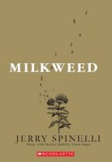
PAPERBACK BOOK

Milkweed

Grades 9 - 12
Newbery Medalist Jerry Spinelli takes us to one of the most devastating settings imaginable—Nazi-occupied Warsaw of World War II—and tells a tale of heartbreak, hope, and survival through the bright eyes of a young orphan.
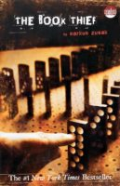
PAPERBACK BOOK

The Book Thief

Grades 9 - 12
Celebrating the way that books and stories unite people in the face of tragedy, this haunting, weighty, and transformative book is impossible to forget.
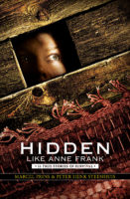
PAPERBACK BOOK

Hidden Like Anne Frank

Grades 9 - 12
Fourteen unforgettable true stories of children hidden away during World War II.

