Name/School/Grade level:
Ann Quackenbush
Next Generation School
Fifth Grade
Lesson/Unit Description:
Stated objectives:
By the end of this unit, students will understand some of the experiences of Jewish people who lived during the Holocaust as well as identify ways that they can show kindness and inclusivity in their own lives.
Academic Standards (Illinois Learning Standards):
Key vocabulary:
- World War II
- Poland
- Ghetto
- Holocaust
- Hitler
- Nazi
- Judaism
- Hebrew
- Yiddish
- relocation
- rations
- deportation
- liquidation
- swastika
Documents provided for students:
Yellow Star by Jennifer Roy
Response Guide for Yellow Star
One Survivor Remembers (video)
Guide for video
Step-by-step procedure for delivering lesson/unit:
- Introduce a short history of the end of World War I/beginning of World War II.
- Provide information about Hiter’s rise to power and the economic situation of Germany without explicitly stating that Hitler was looking for a scapegoat. Students often make that connection themselves.
- Introduce Yellow Star by Jennifer Roy, comparing poetry and prose, and elicit student feedback about how reading a novel in verse is different from prose. (Every phrase holds weight and importance, there is space to think and reflect on what you’ve read.)
- Using the response guide, assign sections of the book as shown. Students record ideas as they read as well as respond to questions to check comprehension. Copy 1 response chart per section, with questions on the back. Quizzes are included after every other reading.
- Be responsive to students’ ideas as shared on the response chart. Discuss questions as they arise and theories of characters’ behavior/motivation, etc. as students identify them.
- In checking questions, also review them with the class. Since many questions have multiple answers, have students put a star on their paper when an answer is given that matches theirs, when the class agrees the answer is suitable. Encourage use of text citation to support ideas and responses.
- After finishing Yellow Star, share another story: One Survivor Remembers. Video is shown in 4 parts, following the instructions in the guide, linked above. Introduce vocabulary and each section using the slides linked in the guide for the video. As students listen to Gerda’s story, they use a response guide (Know/Wonder/Hunch/Pattern) to record thoughts to share after watching the section each day.
- Invite a public speaker to share stories of their own experiences or others during the Holocaust. Guest speakers include Michael Leroy, William Gingold and Brian Kahn.
- Throughout this study, we incorporate what we’re learning into class or small group discussion whenever possible. This includes when there is conflict that needs to be resolved, ensuring that all individuals are being heard and treated with respect. This also includes discussions of bullying and upstanding. Every day provides opportunities to help those who are being mistreated simply for being who they are. This is a life-long lesson.
Assessment plans:
- Check student work on response guides and quizzes with every assignment. Students take more thought and care with their work when they feel someone is truly reading and appreciating their ideas. Share student examples of powerful thinking and empathy. “Max had a really interesting idea about this question. Would you share it with us, Max?” Check for confusions and understandings that need to be “unpacked.”
- At the conclusion of the unit, students work on a class project that allows them to reflect on what they have learned and how they will use what they have learned to help make things better in our classroom and other environments that students inhabit. This project changes each year.
- Example: Word clouds made with students’ ideas about what can and cannot be taken from people. (These ideas are based on 5th graders’ understanding, so I may not agree with all of them, but they are food for discussion and continued learning about the topic.)

What can be taken:
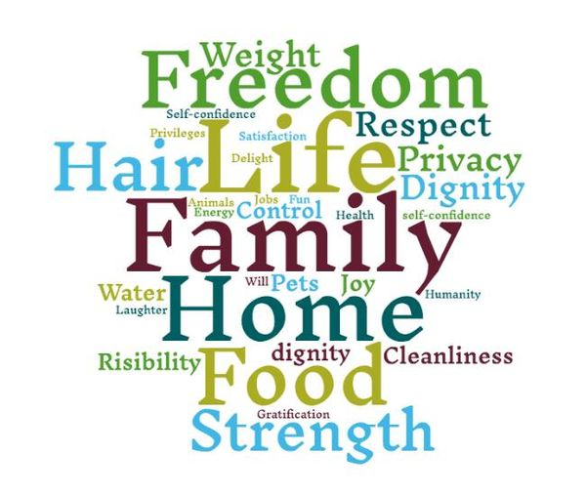

What cannot be taken:

