A Picture Is Worth A Thousand Words
Assignment

While studying the Holocaust and Holocaust Literature, you have had the opportunity to view many photographs at various web sites. This assignment requires that you select one photo to represent all that you have studied in the unit.
It should be a picture that “speaks” to you or conveys a strong message to anyone who sees it. It is as if you have each been asked to select a photo to be put into a book about the Holocaust. Pick something important to you – something you feel we should remember, something you feel the world should know about. Think carefully and choose wisely.
Paste your picture into a Word document. Be sure to place where you got the photo and other important information on this page. Print it out at the “Best Quality” setting or, under “advanced properties,” at a high dots per inch (dpi). No picture should be printed in color and all pictures should be at least 3 x 5 inches in size.
After selecting and learning about your photo, you need to produce a clean, typed copy of a poem that is at least 20 lines long. It must be original and related to the photo. Some poetry formats may be provided on request.
I strongly suggest that you use the USHMM photo archives as a resource. To do this, go to
www.ushmm.org. Open the “Search” and type in “Photo Archives” then click on “Photo Archives” - #2. Scroll down to the “Search the Catalog” button. Now pick a topic like “children” or “Gypsies” and do a search. Be sure you select “historical photo” or you will not be successful.

Other sources may be used, but the assignment must still be followed.

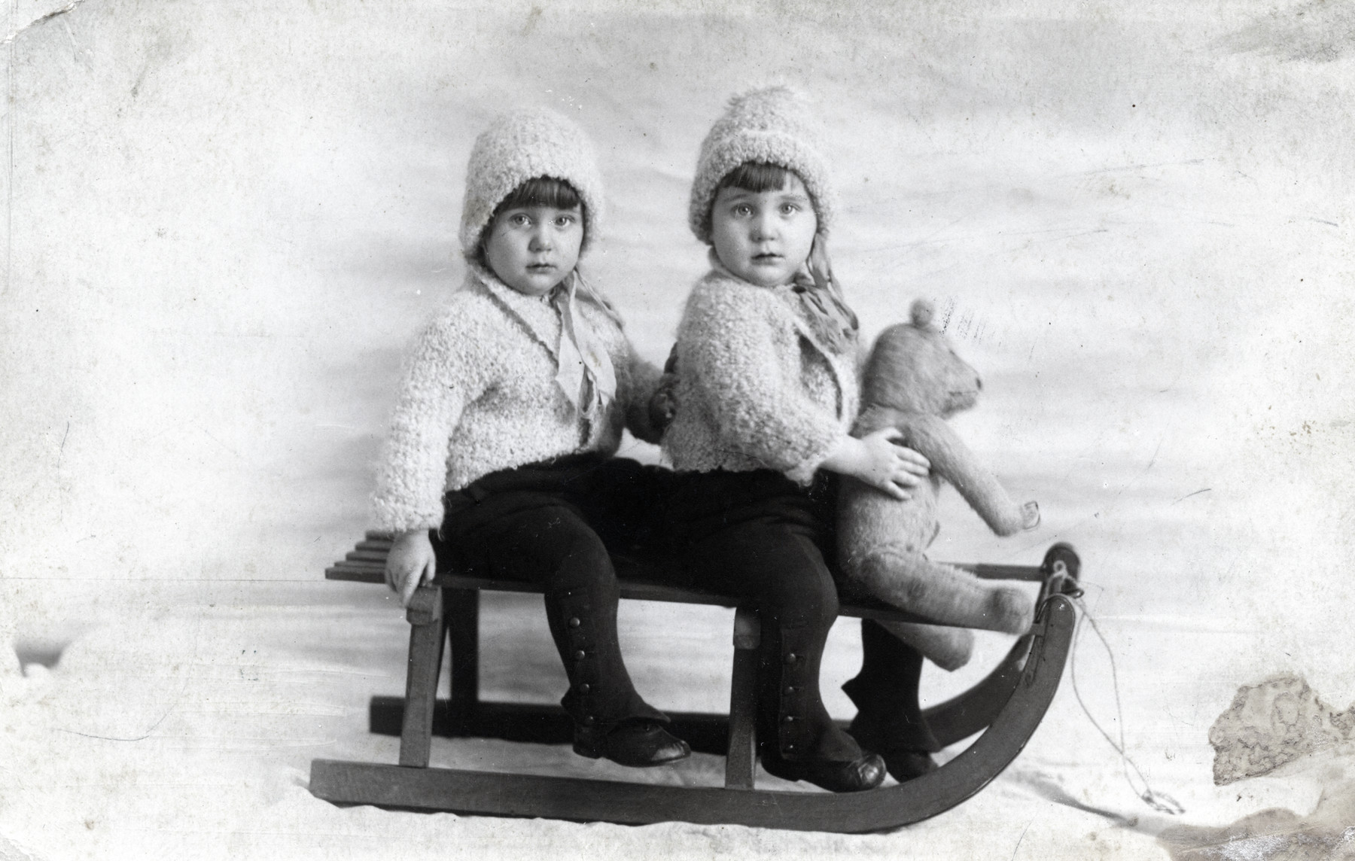
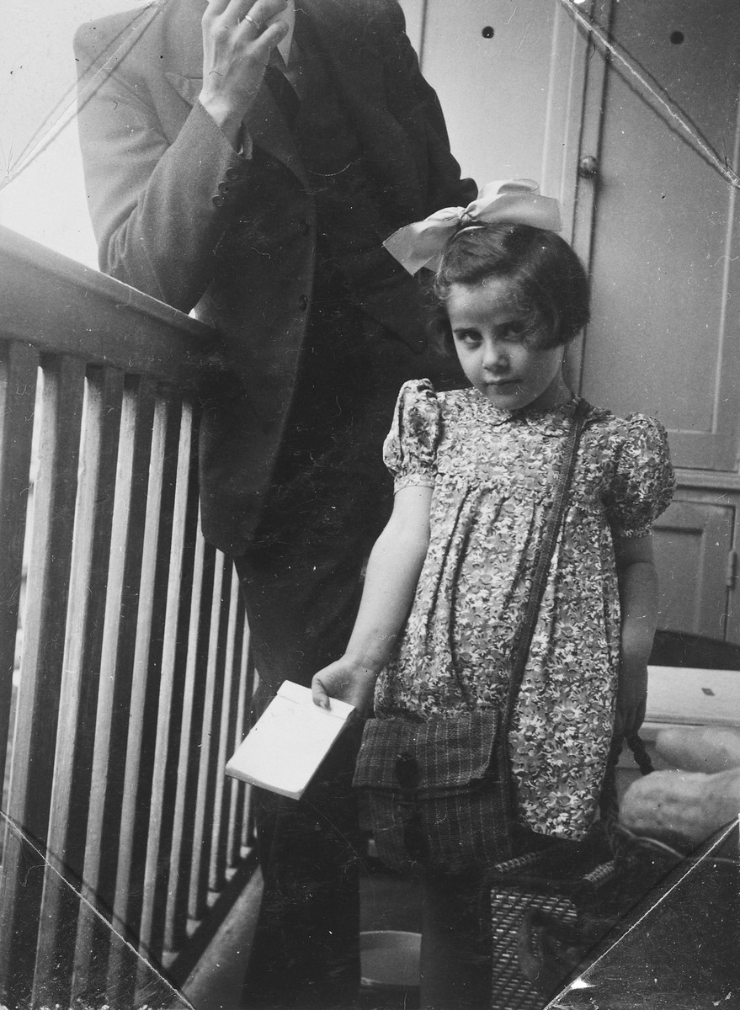

Tell Them We Remember
Due:
Points: 20
Assignment:
Create an 8 ½ by 11 attractive poster in honor/memory of the person
whose ID card number you selected in class.

Requirements:
8 ½ by 11 paper
Photo of person or related art/photo
Name of person
USHMM ID Card ##
Where they were from
Poem (minimum 10 lines) written about them (select one of the formats below or
use your own style – you may need to be somewhat broad or fictionalize
appropriately)

Sources: Go to www.ushmm.org.
Click on “Search”.
Type in “ID Cards”.
Go to #5 - “Museum-Created ID Cards”
Then click “View All Names in List”
(There are other ways to get to the same place)

Suggested Poem Formats:

Character Poem (you may change the verb tenses as needed)
Line 1: Name of character
Line 2: Describing words
Line 3: Who loves
Line 4: Who feels ... about ...
Line 5: Who needs
Line 6: Who shares
Line 7: Who fears
Line 8: Who'd like to see
Line 9: Who dreams of
Line 10: Who ends up (emotion or situation at end of ID Card)

Bio Poem (you may change the verb tenses as needed)

(first name)
(four words that describe them)
Relative of (list close family members)
Resident of (place where they lived)
Who likes (three things they like)
Who loves (three things the love)
Who fears (three things)
Who wishes (three things)
Who admires (three)
Who needs (three things they need)
Who aspires to (at least two aspirations)
(last name)

Extra Credit will be awarded for extra effort! These may be displayed.

ZOFIA YAMAIKA

Born: 1925 in Warsaw, Poland
Died: February 9, 1943, in a forest in Poland

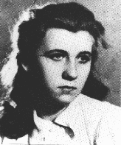

Zofia
Wealthy, Hasidic, Jewish, Fighter
Relative of her dear mother and father
Resident of Warsaw and a forest
Who likes Communism, her parents,
and her fellow partisans
Who loves freedom, fighting for her people,
and the group Spartacus
Who fears Hitler, losing her parents,
and dying before she is 19
Who wishes to go to school, her parents were safe,
and for more training with the machine gun
Who admires resistance fighters, her fellow partisans,
and her parents
Who needs more ammunition, more people with her trying to hold off the Nazis, and to kill the Nazis before they kill her
Who aspires to live or die fighting in the forest near Radom
Yamaika

Source: United States Holocaust Memorial Museum ID Card #596

