Champaign-Urbana Jewish Federation/Holocaust Education Center
Zoom Conference – Teaching the Holocaust and Genocide
August 4, 2020
Speaker Bios

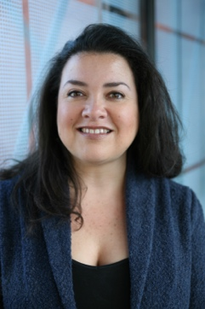
Christina Chavarría: is a Program Coordinator in the Levine Institute for Holocaust Education at the United States Holocaust Memorial Museum, where she has worked since December 2006. She holds a BA and MA in comparative literature from the University of Dallas. Her interests lie in Holocaust literature, engaging new audiences and partners, and studying and disseminating information on the impact and history of the Holocaust in the Ibero-American (Spain, Portugal, Latin America, US Latinx) world. Christina is currently running the Conference for Holocaust Education Centers, a program that builds cooperative relationships with Holocaust organizations in the United States. Previously, she ran the Museum’s Belfer National Conference, Holocaust Institute for Teacher Educators, and managed outreach projects for the Museum Teacher Fellows for six years. Previously, Christina served as Director of Education at Holocaust Museum Houston for six and a half years. Prior to that, she was a high school English teacher for nine years in El Paso,Texas, her city of birth. Christina took part in the USHMM’s Teacher Fellowship program (2000), the Jewish Labor Committee’s Holocaust and Jewish Resistance Teacher Program in Poland and Israel (1998), the Jewish Foundation for the Righteous’ Lerner Fellowship (2001), and studied for two summers at the Jewish Theological Seminary, looking at cultural responses to the Holocaust in the US and abroad. She has worked with audiences all over the United States and in Latin America, Europe, Israel, Jordan, and Japan.

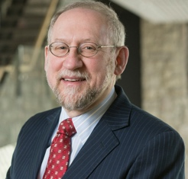

Dr. Paul Finkelman, President Gratz College: received his B.A. in American Studies from Syracuse University in 1971 and his Ph.D. in history from the University of Chicago in 1976. He was later a Fellow in Law and Humanities at Harvard Law School. He has held a number of endowed chairs as a tenured professor or as a visitor, including the Ariel F. Sallows Chair in Human Rights Law at the University of Saskatchewan, the John Hope Franklin Chair in American Legal History at Duke Law School, and the President William McKinley Distinguished Professor at Albany Law School. In 2017 he held the Fulbright Chair in Human Rights and Social Justice at the University of Ottawa School of Law, in Ottawa, Canada and was also the John E. Murray Visiting Professor at the University of Pittsburgh School of Law. He is the author of more than 200 scholarly articles and the author or editor of more than fifty books. His most recent book, Supreme Injustice: Slavery in the Nation’s Highest Court, was published by Harvard University Press in 2018.
He has published in a wide variety of areas including American Jewish history, American legal history, constitutional law, and legal issues surrounding baseball. His work has been cited in five decisions by the United States Supreme Court. Most recently Justice Ginsburg quoted him in her unanimous decision in Tims v. Indiana. He has been quoted in numerous other courts, and in many appellate briefs. He has lectured on slavery, human trafficking, and human rights issue at the United Nations, throughout the United States, and in more than a dozen other countries, including China, Germany, Israel, and Japan. In 2014, he was ranked as the fifth most cited legal historian in American legal scholarship in Brian Leiter’s “Top Ten Law Faculty Scholarly Impact, 2009-2013.” He was an expert witness in the famous Alabama Ten Commandments Monument Case (Glassroth v. Moore) and in the law suit over the ownership of Barry Bonds’ 73rd home run ball (Popov v. Hayashi).

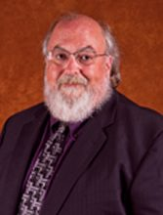

Dr. Brian Kahn: Brian B. Kahn is a retired associate professor of Teacher Education at the University of Illinois at Springfield. He has been teaching the Holocaust since the early 1990’s, both at the secondary and post-secondary levels and has published several articles in national and international journals dealing with this subject. Currently, he serves as the chair for the Holocaust Education Center of the Champaign Urbana Jewish Federation, while also speaking in area classrooms and sharing the legacy of his family’s experiences during the Holocaust.

Rebecca Lawson: is an English teacher at Sullivan High School in Sullivan, Illinois. She has a B.A. in English and in journalism, a Master’s in Education, and a Master’s in English (Creative Writing) from Eastern Illinois University. ·She has received several national and state fellowships: the Belfer Teaching Fellowship at the United States Holocaust Memorial Museum (1994); the National Endowment for the Humanities Summer Seminar Fellowship for Theatre of the Holocaust, University of Wisconsin, Madison, WI (1994); the Mandel Teacher’s Fellowship at the United States Holocaust Memorial Museum (1996); the National Endowment for the Humanities Seminar Fellowship at the National Institute on Teaching Shakespeare, Shakespeare & Company/Simon’s Rock College, Great Barrington, MA (1996); the Holocaust and Jewish Resistance Teacher’s Fellowship (sponsored by the American Gathering of Jewish Holocaust Survivors, the Jewish Labor Committee, and the American Federation of Teachers) (1998); the Leo and Antonia Gershanov Teaching Fellowship at the Illinois Holocaust Museum, Skokie, IL (2004); and a Teacher Fellowship with the Eastern Illinois Writing Project, Eastern Illinois University (2011). She has directed two Holocaust plays (Who Will Carry the Word? and I Never Saw Another Butterfly) and has worked extensively on teaching Holocaust literature, especially through drama, poetry, and Elie Wiesel’s Night. She has presented throughout the region about Holocaust literature. She has also helped organize several Holocaust workshops and visits to her community and area schools by Holocaust survivors. A member of the Champaign-Urbana Jewish Federation’s Holocaust Education Center for over 20 years, she has been honored for her outstanding innovation and dedication to Holocaust education.

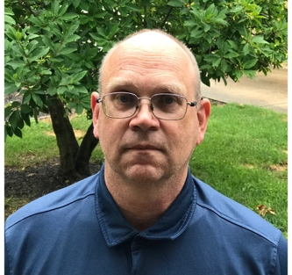
Bob Lehmann: is a teacher at Westville Senior High School and a doctoral candidate in Holocaust & Genocide Studies at Gratz College, Philadelphia, PA. His research interests and dissertation project will be focused on the efforts of Orthodox Christians in rescue and resistance operations during the Holocaust. Bob was selected to be an interviewer for the video history project Survivors of the Shoah and has received two national fellowships in Holocaust education, research: the United States Holocaust Memorial Museum’s Teacher Fellowship (1998) and the Holocaust and Jewish Resistance Teacher’s Fellowship (2000). He is an active committee member of the Champaign-Urbana's Jewish Federation's Holocaust Education Center for over 20 years and has coordinated and presented at many of their educator seminars on various aspects and topics of the Holocaust history and pedagogy. Additionally, he has presented on the Holocaust for the U.S. Army in Kuwait, and at other educator and community events and workshops around the Midwest. He received his BA in History from Western Illinois University, an MA in Secondary Education from Northern Michigan University and an MA in History with a Graduate Certificate in European History from American Public University.

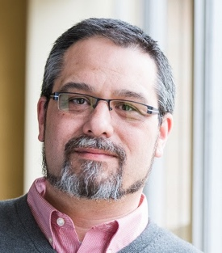

Kerri J. Malloy (Yurok/Karuk) is a Lecturer in the Department of Native American Studies at Humboldt State University. He is also, the Community Outreach Director for the Center for Genocide Research and Educaiton in Longmont, Colorado. He received his Master of Jurisprudence in Indian Law from The University of Tulsa College of Law, and both his Bachelor of Arts in Native American Studies and Economics from Humboldt State University. He is a doctoral candidate in the Holocaust and Genocide Studies Ph.D. program at Gratz College. He focuses his research on the Indigenous genocide, healing, and reconciliation in the Americas; and the necessity of systemic change within structures to advance transitional justice.

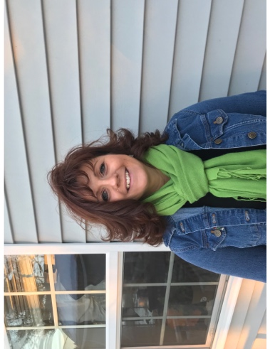
Heidi Omlor: has been teaching Social Studies for 20 years at the high school and college levels. Earned a BA in History from the University of Maine, a MA in Holocaust and Genocide Studies from Gratz College, and is a current Ph.D. candidate in Holocaust and Genocide Studies at Gratz College. Currently working with the Maine State Legislature to make Holocaust education in the State of Maine mandatory. Lives in Maine with her husband, Pete, cat Charlie, and dog Izzy. Has 2 grown children, 3 grown stepchildren and 2 grandchildren, Blair and Grace.

Collen Simon: is a middle school humanities teacher from West Hartford, CT. She is also the Education Director for the Center for Genocide Research and Education (CGRE) located in Longmont, CO where she is currently working on creating a course in comparative genocide studies for high school seniors to be taken for college credit. Colleen is a member of the Board of Directors of Voices of Hope which was founded by the families of Holocaust Survivors in CT. She is a Ph.D. student in the Holocaust and Genocide Studies Program at Gratz College. Her research focuses on the role of choice and acts of rescue during the 1994 genocide in Rwanda. Last summer Colleen traveled to Rwanda with Carl Wilkens (the only American who chose to stay during the genocide) and has been learning more about transitional justice and healing after genocide.

