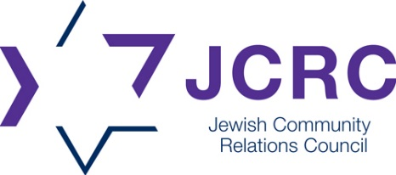
CONTACT
Brant Schulz
Assistant Communications Manager
bschulz@jfedcin.org
C: 513-675-6819

FOR IMMEDIATE RELEASE / TUESDAY, MARCH 25, 2025

STATEMENT REGARDING SENATE BILL 1
Cincinnati — Since the introduction of Senate Bill 1 (S.B. 1), the Jewish Community Relations Council (JCRC)—the public affairs arm of the Jewish Federation of Cincinnati—has been actively monitoring the bill’s development and advocating against provisions that threaten Ohio’s higher education system. From the outset, our concern was broad: legislation targeting programs based on arbitrary criteria, such as graduation rates, poses significant risks to educational diversity and institutional integrity.
In response, we engaged directly with the bill’s sponsors and visited the statehouse, urging lawmakers to amend S.B. 1 to protect at-risk programs, including Judaic Studies at the University of Cincinnati. Despite these efforts, the bill passed the Ohio House last week without amendments.
Now that S.B. 1 has passed both the Senate and the House, the JCRC’s focus shifts to working within the bill’s framework to advocate for programs and resources essential to Ohio’s educational landscape. We are preparing to meet with officials responsible for granting waivers and will advocate for the protection of vulnerable programs that contribute to the integrity of higher education in Ohio.
This effort is about more than safeguarding one program—it is about ensuring that valuable academic and institutional resources remain accessible to all. The JCRC remains steadfast in its commitment to pursue every available option to protect the Judaic Studies program and other essential offerings that enrich Ohio’s educational landscape.
# # #

About the Jewish Community Relations Council
The Jewish Community Relations Council (JCRC) is the non-partisan public affairs arm of the Jewish Federation of Cincinnati. Its mission is to protect Jewish security, recognizing that Jewish security depends on a just society for all. To achieve this mission, it advocates for the local Jewish community through Israel education; fighting antisemitism, discrimination, and racism; and building understanding with other ethnic, religious, and civic organizations. For more information, please visit jewishcincinnati.org/jcrc

