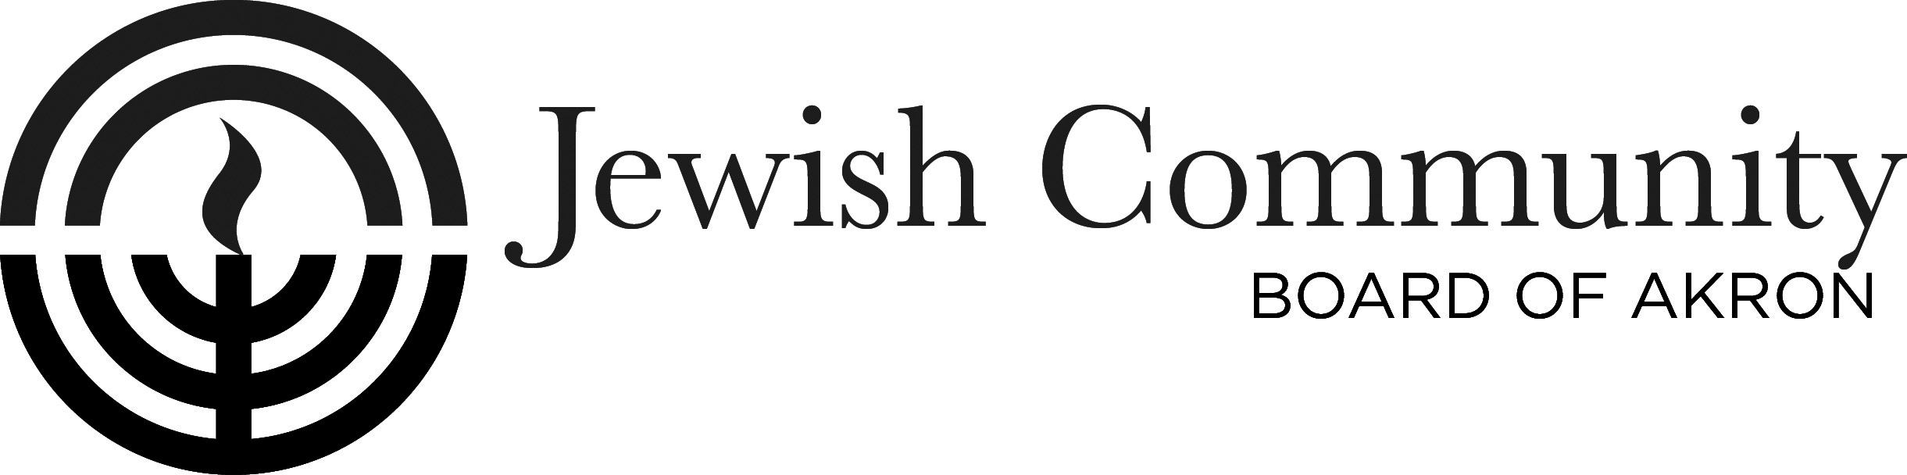
Invites you to enroll in

Encountering Jewish Culture: through Stories, Poetry & Art: 2019 – Part III

Jewish American Literature -
Selected stories thru time -continued

We will read and discuss selections of Jewish American Writing from 20th and 21st century. Though our book spans 350 years, including —fiction, poetry, drama, essays, letters, editorials, journals; we will focus on selections from contemporary times. Do Jews writing in America make up a literary tradition? If so, what defines that tradition? Invite friends to join in discussions; or give contact info to Esther Hexter. Everyone is welcome to join our conversation. No prerequisite, only desire to learn.

With
Esther Cohen Hexter

Time: 6 Wednesdays, 11:00 AM-12:45 PM
Sept. 11, 18, 25, Oct. 16, 23 & 30, 2019

Location: Schultz Campus for Jewish Life in Shaw JCC
750 White Pond Dr., Akron, OH 44320

Text: Jewish American Literature: A Norton Anthology, edited by Jules Chametzky, John Felstiner, Hilene Flanzbaum & Kathryn Hellerstein [Students provide own or borrow book]

Fee: Class: $25.00

Register: By mail or in person: Registration deadline: Sept. 6, 2019

Courtesy of grant from: Edward I. Abramson Program Fund, Jewish Community Board of Akron
-----------------------------------------------------------------------------------------------------------------------------
Jewish American Literature Part III - Registration Form

Name__________________________________________ Home Phone_________________________

Address_________________________________________City/State/Zip________________________

Work or Cell Phone _______________________E-mail ______________________________________

Minimum registration required. [Use own or borrow book.] Class Fee: $25. Registration Deadline- Sept. 6, 2019
Register by Mail or in person. Amt. Enclosed ____ payable to: “JCBA”, to: JCBA, c/o Jewish Stories, 750 White Pond Dr., Akron 44320 Questions: eshexter@juno.com or 330-836-0777
www.jewishakron.org/all-meetings/JewishAmericanWriting.

