LESSON: Israel Bornstein

Grade Level:
This unit was developed for secondary students. The approach and materials for this unit follow the Age Appropriate Guidelines from the USHMM.

Subject:
History; English/Language Arts; Multi-disciplinary.

Rationale:
The stories of individuals during the Holocaust can help us understand various facets of history through the eyes of those who lived through it. This story helps to broaden understanding about the experience of a young Danish Jewish man whose survival through the daring rescue effort by Danish fishermen shares a unique story during the Holocaust. Note: This lesson ties in resources from Echoes & Reflections unit: Rescuers and Righteous Among the Nations.

Overview:

Key Question(s):
- Who was Israel Bornstein? What was his experience during the Holocaust?
- How was the experience of Israel different from that of other survivors of the Holocaust that you may have learned about?
- How did community members risk their lives to help Israel and his fellow Jews survive?

Educational Outcomes. At the end of this lesson, the students will be able to:
- Define the Holocaust and related terms such as Orthodox, shochet, Talmud and Rosh Hashanah.
- Identify who Israel Bornstein was and what his journey was like during the Holocaust.
- Compare and contrast information shared in text and in a podcast.
- Explore reasons why community members may have chosen to participate in this large-scale rescue effort.
- Describe what it means to be altruistic.
- Provide ways individuals can demonstrate altruism in their daily lives.

Teacher preparation
It’s important for teachers to familiarize themselves with the Pedagogical Principles for Teaching the Holocaust. We encourage teachers to familiarize themselves with background knowledge on the Holocaust by viewing this site at the USHMM and view the Introduction to the Holocaust. Additional information on teaching about this topic can be learned from the full-length version of The Path to Nazi Genocide.

In addition, we suggest:
  - Prepare access to handout and student packet.
  - Check access to related links.
  - Consider having students complete the What was the Holocaust? Activity.
  - Identify any terms students may be unfamiliar with in the written text or the podcast.

Materials
- Israel Bornstein’s narrative in To Life: The Past is Present
- Israel Bornstein Podcast: The Elsinore Sewing Club
- Character Map Example
- Handout Quotes: Danish Rescue and Resistance
- Handout: Rescue in Denmark

Lesson:

INTRODUCTION
- If students have not previously discussed the Holocaust, begin with an overview of the term, Holocaust, as defined by the United States Holocaust Memorial Museum:

The Holocaust was the systematic, state-sponsored, persecution and murder of six million Jews by the Nazi regime and its collaborators between 1933 and 1945 across Europe and North Africa. The height of the persecution and murder occurred during World War II. By the end of the war in 1945, the Germans and their collaborators had killed nearly two out of every three European Jews. The Nazis believed that Germans were racially superior.

They believed Jews were a threat to the so-called German racial community. While Jews were the primary victims, the Nazis also targeted other groups for persecution and murder. The Nazis claimed that Roma, people with disabilities, some Slavic peoples (especially Poles and Russians), and Black people were biologically inferior. The regime persecuted other groups because of politics, ideology, or behavior. These groups included Communists, Socialists, Jehovah’s Witnesses, gay men, and people the Nazis called “asocials” and “professional criminals.”

For younger students, or students previously familiar with this event in history, you can utilize this shortened definition:
The state-sponsored systematic murder of approximately six million Jews by the Nazis and their collaborators. Sinti-Roma, Poles, people with physical and mental disabilities, homosexuals, Jehovah's Witnesses, Soviet prisoners of war, and political dissidents were also targeted by the Nazis.

- Share with students that today we will be learning about the story of Israel Bornstein. Israel was a young Danish Jewish man who was saved as part of a large rescue effort.
- Ask students to respond to the statement: In psychology, the “bystander effect” says the more people there are who witness someone in distress, the less responsible each individual feels to help. The likelihood that a person will receive help decreases as the number of witnesses increases. Discuss one instance in which a group of people neglected to help or acted to help someone in need. Why do you think the group behaved as it did in that instance? How do you think the bystander effect impacted society’s reaction to the murder of George Floyd in 2020?
- Share with students that during this lesson, they will explore a specific group who helped Jewish victims of the Holocaust in Denmark despite the many risks that accompanied this rescue effort.

RESEARCH/ANALYSIS/CREATION/COMMUNICATION
- Explain to students that they will be assigned one of two ways to learn about Israel and the way he was rescued during the Holocaust - through a podcast or through a written narrative. Each group will read/listen then create a character map of the people who are part of their media version of Israel’s experience.(A sample character map from a similar story is include in the Appendix)
- Upon creating the character map, share the handout, Quotes: Danish Rescue and Resistance. (As there are only 12 quotes, more than one student may receive the same quote.) Students should move around the room and find a partner. The partners will then read aloud and discuss their quotes. They add new “characters” to their maps, noting the motivations of rescuers. Students find a new partner and repeat this process until they have considered at least three quotes.
NOTE: These quotes focus on individuals who were part of the Danish resistance and opposed Nazi efforts. It should be noted that there were also a significant number of Nazi sympathizers in Denmark, making the efforts of rescuers especially risky. The National Socialist Workers' Party of Denmark arose in 1930, several years before the election of Adolf Hitler. The party in Denmark mirrored the Nazi Party in Germany in many ways, adopting its swastika and Hitler salute and espousing antisemitic beliefs, though not as virulent as in Germany.
- Next, individually or in pairs, students should read the Rescue in Denmark handout for additional context on the rescue operation. They should be directed to annotate the handout by highlighting the roles and motivations of people who helped Jews, focusing particularly on “The Elsinore Sewing Club.” Students should then continue to add information to their character maps.
- Finally, ask students to share their character maps in small groups and identify common behaviors and motivations across the various members of Danish society.

CONCLUSION
- To conclude the activity, gather students together and discuss all or some of the following:
  - How was the situation for Danish Jews different from that of Jews in other German-occupied countries? How did things change beginning in 1943?
  - How and why did members of “The Elsinore Sewing Club” get involved in rescue efforts? What consequences did they suffer for their actions?
  - In general, what commonalities did you observe regarding the motivations of Danish people who supported the rescue efforts? What were their stated reasons for helping?
  - Why do you think so many Christian Danes were willing to aid Jewish people when antisemitism throughout Europe was so widespread?
  - What types of cultural and political systems in a nation allow for moral action such as the rescue in Denmark?
- Have students conclude the activity by creating an exit ticket that provides one understanding from today’s lesson that can impact their lives today.

Appendix:

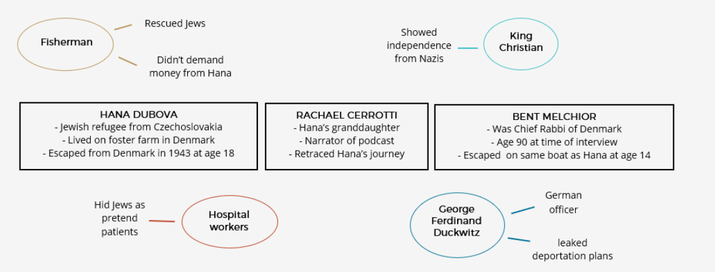

https://www.dictionary.com/e/tech-science/bystander-effect/

