
- By Jewish Link Staff
- | March 12, 2025
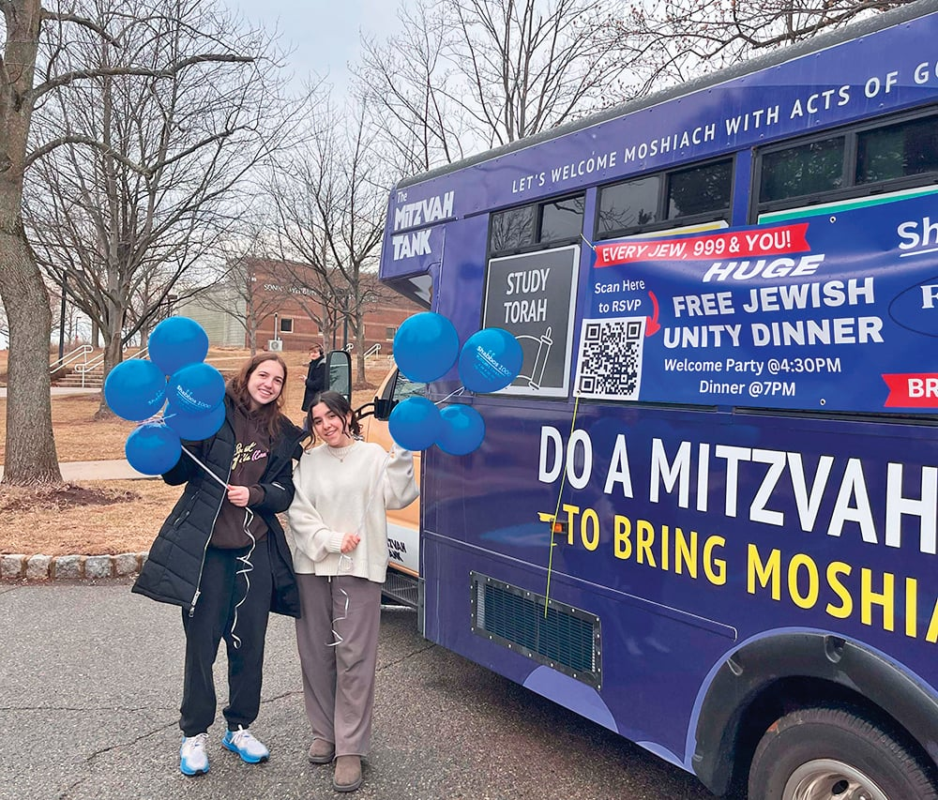
(Courtesy of Rutgers Chabad) The Chabad House at Rutgers University hosted a remarkable gathering as 1,000 Jewish students came together to welcome Shabbat in an atmosphere of unity and pride. This annual event, known as Shabbos for 1000, took place this past Shabbat Terumah, March 1, in the Grand Ballroom of the Chabad House, creating an inspiring and uplifting experience for all participants.
A powerful sense of Jewish identity marked the evening, as students from diverse backgrounds joined in prayer, song and a festive Shabbat meal. The event was a true testament to the strength of Jewish life on campus, with all Jewish organizations, including Rutgers Hillel, RJX, Rutgers Students Supporting Israel (SSI at Rutgers), Israeli American Council (IAC), JLIC-Rutgers, AEPi, Sigma Phi, and the Jewish Federation in the Heart of New Jersey, uniting to support and celebrate this special occasion.
Under the leadership of Rabbi Yosef Carlebach, Rabbi Baruch Goodman and Rabbi Yeshaya Shagalov, Rabbi Mendi Pevzner, Rabbi Mendy Carlebach and Shaindel Polichenco, the Rutgers Chabad House continues to be a beacon of Jewish community, providing a warm and welcoming space for students year-round.
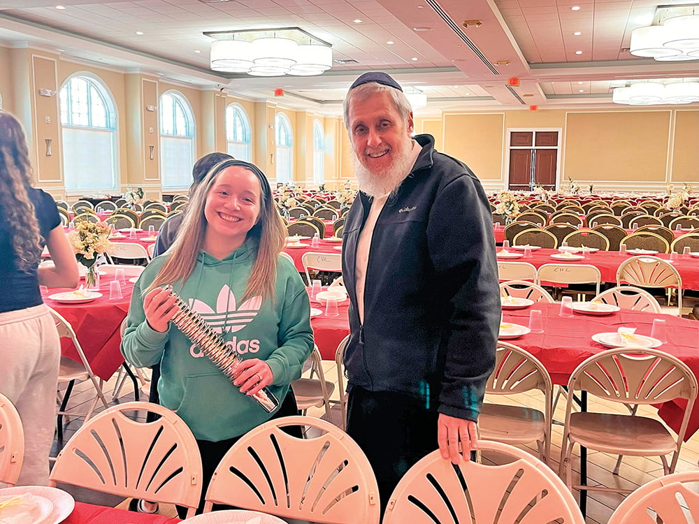
As the largest Jewish student event of the year, Shabbos for 1000 at Rutgers Chabad House once again demonstrated the power of tradition, community and the enduring spirit of Jewish pride.
For more information on Jewish life at Rutgers University (including Jewish housing, kosher meals and Jewish Campus Experience), contact Rutgers Chabad at info@chabadnj.org or call (732) 296-1800. Rutgers Chabad is located at 170 College Ave., New Brunswick, and has been doing outreach on campus for 47 years.
