

Jewish Federation Event Looks at Preventing, Addressing Antisemitism in Schools
- By Harry Glazer
- December 12, 2024
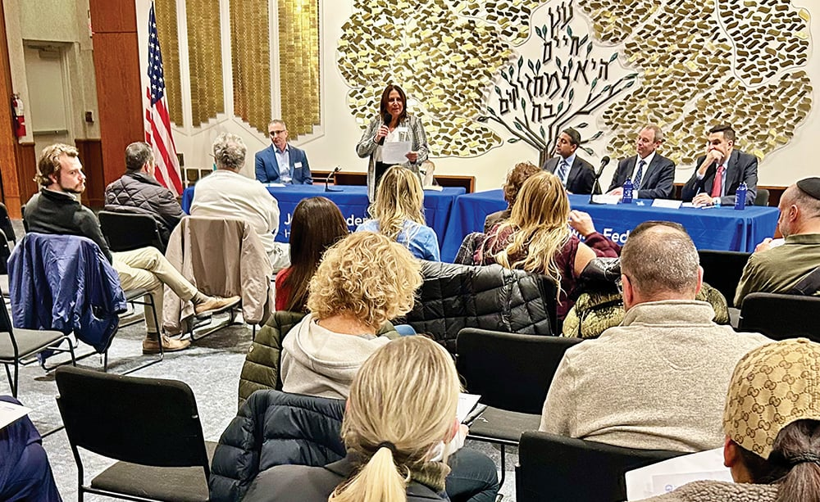
Federation’s Amy Keller opens the event.
One clear sign that the Jewish Federation in the Heart of New Jersey’s (Federation) program on December 4 was addressing a real need in the community was apparent in the appreciable number of people showing up early and saving seats for their friends.
Federation, in conjunction with its Jewish Community Relations Council (JCRC) and security initiatives, the New Jersey/New York office of the ADL, and Federation’s new arm—the Center to Combat Antisemitism and Reinforce Multicultural Acceptance (CARMA)—held a workshop on Preventing and Responding to Antisemitism at Temple Shaari Emeth in Manalapan that attracted dozens of interested attendees.
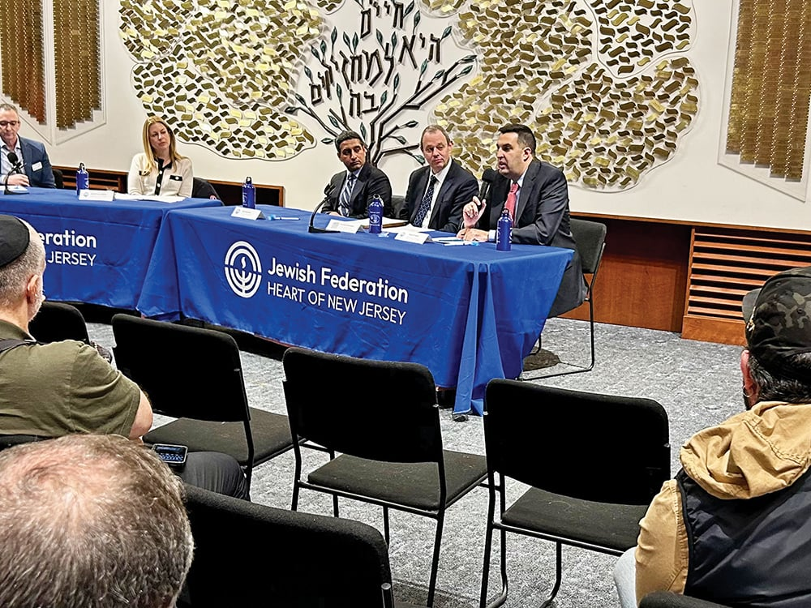
Panelists speak.
The workshop featured an impressive range of guest speakers, all well versed on the topic at hand:
Brandi Katz Rubin, deputy regional director of ADL New York/New Jersey;
Sundeep Iyer, director of the New Jersey State Division on Civil Rights;
David Krieger, senior attorney at the Department of Education’s Office for Civil Rights in New Jersey;
Michael Campion, chief of the Civil Rights Division, United States Attorney’s Office for the District of New Jersey; and
Monmouth County Prosecutor Raymond S. Santiago.
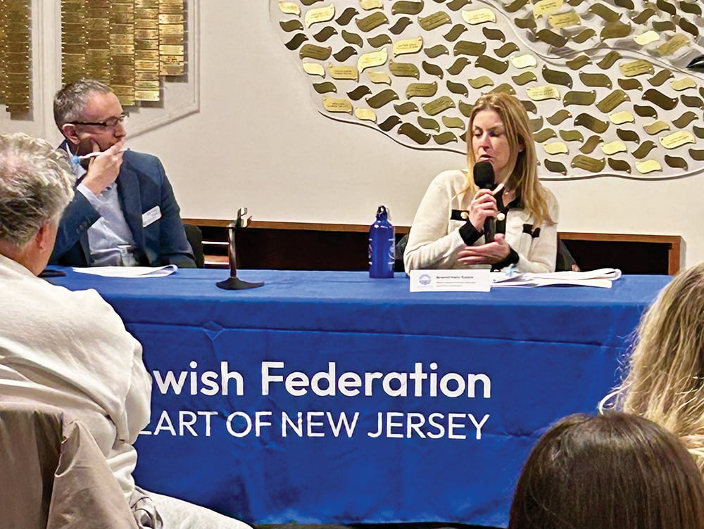
Brandi Katz Rubin, of the ADL NY/NJ, right, speaks as Federation’s Dan Rozett looks on.
There were 20 educators present, including Dr. Lester Richens, the Monmouth County executive superintendent; Dr. Nicole Hazel, superintendent of the Freehold Regional High School district; and Michael Ballone, superintendent of the Marlboro Township Public Schools.
The event was moderated by Dan Rozett, Federation’s director of community relations and Israel engagement.
The Jewish Link asked a few attendees what drew them out to attend this event, on a school night, with a forecast of the first snowstorm of December.
“There have been incidents of antisemitism in the Marlboro Middle School,” said Fortune Cheney of Manalapan. “The Jewish community needs to be protected and the others need to know that people are people.”
“This briefing is important to us,” said Robert Miller, supervisor of school counseling and wellness at Rumson-Fair Haven Regional High School, and the father of a student in Marlboro Middle School. “It is so worthwhile to come, to work together to find solutions.”
“I grew up in Marlboro and from a young age, I’ve seen hateful acts against the Jewish community,” said Jenna Corraro, a new member of the Marlboro Board of Education, a former teacher, and now a professor of English at Drew University in Madison. “I believe that lifelong learning and embracing differences are very important.”
Amy Keller, director of security initiatives and external affairs at Federation, opened the program. Rabbi Melinda Panken of Temple Shaari Emeth greeted attendees, stating: “We are happy to host this event and heartbroken that we have to.”
Rozett asked the governmental guest speakers to comment on the work of their offices. Iyer said that the Division of Civil Rights is charged with enforcing the New Jersey law against discrimination, which is “one of the nation’s oldest and strongest statutes.” This law covers incidents in employment, housing and “places of public accommodation,” which includes schools and colleges.
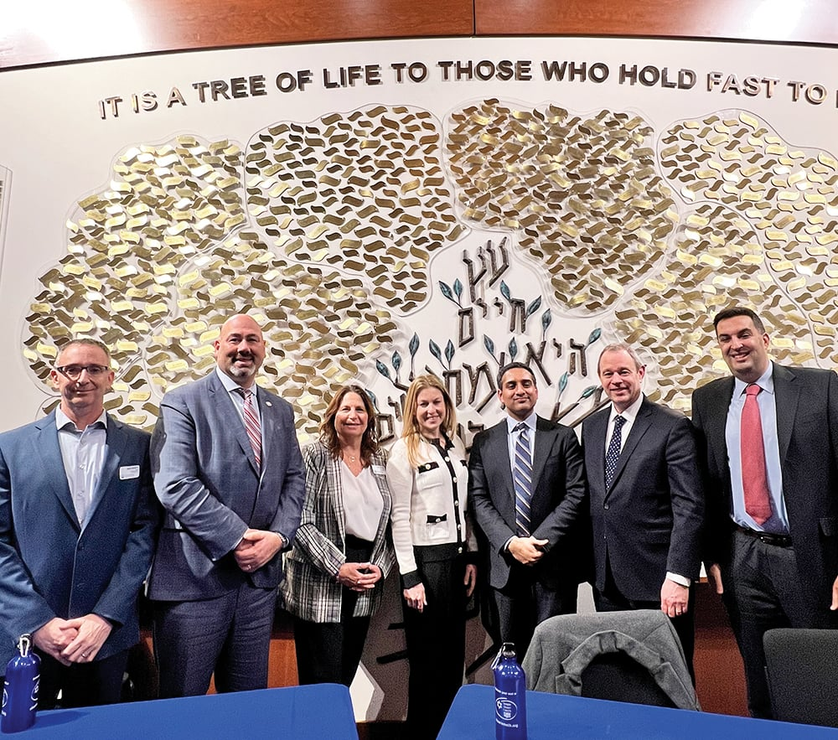
(l-r) Dan Rozett, director, Community Relations and Israel Engagement, Jewish Federation in the Heart of New Jersey; Monmouth County Prosecutor Raymond S. Santiago; Amy Keller, director of security initiatives and external affairs, Federation; Brandi Katz Rubin, deputy regional director of ADL New York/New Jersey; Sundeep Iyer, director of the New Jersey State Division on Civil Rights; Michael Campion, chief of the Civil Rights Division, United States Attorney’s Office for the District of New Jersey; David Krieger, senior attorney at the Department of Education’s Office for Civil Rights in New Jersey.
Campion said that his office is part of the federal government and he serves as the chief prosecutor who enforces civil laws, under Title IV and Anti-Discrimination Statutes. Krieger works to enforce Title VII of the United States Civil Rights Act. He shared that if a complaint is deemed viable, and the institution won’t resolve it, his office can work to rescind federal funding. They can also mediate to resolve complaints.
Rozett asked Rubin what the ADL has observed in terms of statistics in antisemitism. Rubin stated that surveys of the general population show that the number of people who accept a few antisemitic tropes has gone up markedly, from 10% previously to 25% currently. The previous year was record-breaking, with the number of reported incidents of antisemitism in New Jersey up 103%. In the fourth quarter of 2023, the number of antisemitic incidents in schools rose 78%.
Iyer shared that the state has seen “an exponential growth in bias incidents in recent years,” as reports have quadrupled. As one measure, in 2021 there were 350 incidents that targeted Jews, while in 2023 there were 700. In 2022 and 2023, schools were the No. 1 site of bias incidents.
Krieger stated that his office now posts reports of active investigations on its website. There are now 161 open investigations nationwide, with 127 opened after October 7, 2023. There are 37 cases pending in New Jersey, with 29 opened after October 7, 2023. These cases include claims of discrimination and harassment at colleges and public schools, including five open investigations at Rutgers and two at the Montclair public schools.
Campion said that while remarks, even repugnant ones, are allowed under the First Amendment, they cross the line into illegal behavior when the speech conveys a threat to commit violence at a specific target. So, for example, while protesters chanting “From the river to the sea, Palestine will be free” are engaging in free speech, if they chant a threat to harm nearby counter-protesters, that can be actionable.
Iyer added that schools have a legal obligation to respond to speech that creates a hostile environment, even if it falls within First Amendment rights. What constitutes a hostile environment? “Speech or conduct that is specifically pervasive that it effectively denies students the ability to participate in school programs.” Krieger said that while free speech can’t be punished, it can rise to the level of a Title VII violation. If students don’t feel safe going to a school activity, that can indicate a violation.
Rozett asked what families can do if they feel their child has been subject to an antisemitic incident. Rubin said: “Report, report, report, because data drives policy and schools cannot respond without a report.” She added that the ADL will work with an affected family and connect them to the appropriate state or federal office.
Campion urged parents not to censor themselves if they are not completely sure the incident is a crime. He said, “Let us [the U.S. Attorney’s office] figure it out,” and said that even if it’s not a crime, it may be part of a larger situation that warrants government attention.
Krieger said that schools only have an obligation to respond if they have received an actual notice of a complaint. He stressed to parents: “Put your notice in writing. You need a record of who said or did what, to whom, when and where.” He added that best practice is to put the notice in an email and to include relevant screenshots.
Rozett asked: If an incident is reported, what is the school’s obligation? Iyer said that New Jersey’s Anti-Bullying Bill of Rights has very specific regulations for schools to follow. When there’s an allegation, the timeline requires almost immediate reporting to the principal and superintendent. The school has 10 days to investigate and report back to the family filing the complaint.
Federation invited attendees, and community members, to contact them if they have any concerns in these areas. Their contact information is:
Amy Keller, director of security initiatives and external affairs: amyk@jewishheartnj.org
Dan Rozett, director, community relations and Israel engagement: danr@jewishheartnj.org
Stacy Gallin, director, CARMA; stacyg@jewishheartnj.org
“Offering a program like this for both parents and representatives from school districts in Monmouth County ensures that everyone is on the same page when it comes to identifying and preventing antisemitism in schools. It also helps build a sense of trust and transparency within the community, so that parents know that their voices are being heard. That’s part of why we ran this program,” said Gallin.
Susan Antman, executive director of Federation, stated after the event: “Federation is deploying more resources into education and advocacy to combat antisemitism and help proactively ensure safety and security of our community in the heart of New Jersey, in cooperation with key partners on the statewide and local level, who are also doing great work. This event is one of many of our efforts and we are happy to have three skilled staff members focused on this vital work.”

