
Addressing & Combating Hate
By Debra Rubin
January 1, 2025
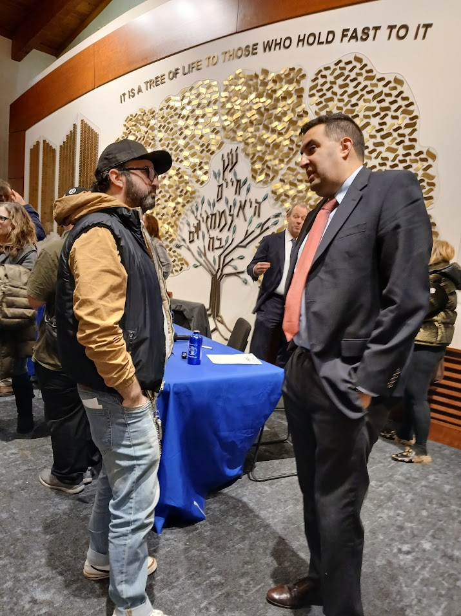
David Krieger (right), senior attorney at the federal Department of Education’s Office for Civil Rights strongly urged reporting of bias incidents. (PHOTOS BY DEBRA RUBIN)

Alarming Rise in Antisemitism in Public Schools topic of Panel Discussion
Since the Oct. 7, 2023 attack on Israel by Hamas, the Jewish community has become alarmed over the skyrocketing rate of antisemitism locally and nationally.
However, it might be surprising to learn that those rates have been surging for years, and even more shocking, for the last two years most reported antisemitic incidents in New Jersey have occurred in the public schools.
That fact was the motivating force behind the panel discussion, Preventing and Responding to Antisemitism in Schools, held Dec. 4 at Temple Shaari Emeth in Manalapan. The panel, sponsored by the Jewish Federation in the Heart of New Jersey in partnership with the Anti-Defamation League (ADL), New Jersey Division on Civil Rights (NJDCR), federal Attorney’s Office of Civil Rights Division and the federal Department of Education’s Office for Civil Rights, featured local, state and federal authorities speaking of the reasons behind the surge, what can be done to stem the rise and how their agencies respond to incidents.
Brandi Katz Rubin, deputy ADL regional director for New York/New Jersey, drove home the point of how concerning the rise of antisemitism has been for officials, noting that the panel was created about six months before the Oct. 7 attack.
Concerningly, antisemitic incidents in New Jersey spiked 103 percent between 2022 and 2023 with statistics for the first quarter of the year showing little difference with those of the last quarter, which Katz Rubin noted, indicates the hate is being driven not only by the war, but by classic antisemitic tropes such as the blood libels and inordinate Jewish control of the media and financial world. The uptick was particularly pronounced around April 20, Hitler’s birthday. The statistics included a sharp 78 percent increase in K-12 public schools over 2022, itself a record-setting year for antisemitic incidents.
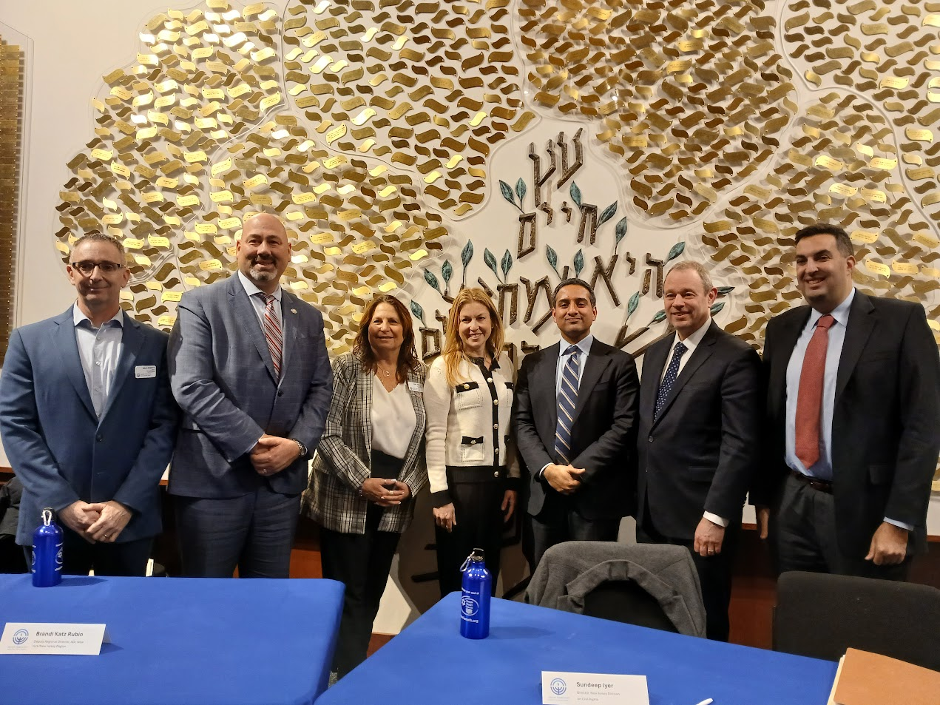
Federation leaders and participants in a panel discussion on preventing and responding to antisemitism sponsored by the Jewish federation and local, state and federal agencies from left are: Dan Rozett, Raymond Santiago, Amy Keller, Brandi Katz Rubin, Sundeep Iyer, Michael Campion and David Krieger.
NJDCR director Sundeep Iyer, said his agency is charged with enforcing civil rights protections in the state through what he termed the nation’s oldest “and one of the nation’s strongest” anti-discrimination statutes. As such, he and other panelists stressed incidents of bias and discrimination should always be reported. Iyer said the state’s figures on antisemitism mirrored the findings of the ADL, with school-based incidents jumping from 350 in 2021 to 700 in 2023.
Iyer said for New Jersey residents that is especially relevant because it “is one of the only states in the country where all the data is centralized,” meaning that he is made aware of every attack and incident reported to local, county or state authorities. Additionally, the state’s “model” Anti-Bullying Bill of Rights, requires districts to protect students from harassment, intimidation and bullying.
“I get every single bias incident every single day on my desk,“ said Iyer. “We also know that for every incident that gets reported there are many others that don’t.”
David Krieger, senior attorney at the federal Department of Education’s Office for Civil Rights, said his office, which investigates bias discrimination in colleges and schools—including antisemitism—currently has 35 open cases in New York and New Jersey, 29 started after Oct. 7. They include Rutgers and Princeton universities, the New Jersey Institute of Technology and Ocean Township public schools. Krieger is based in Manhattan and is responsible for the region covering New York, New Jersey Puerto Rico and the Virgin Islands.
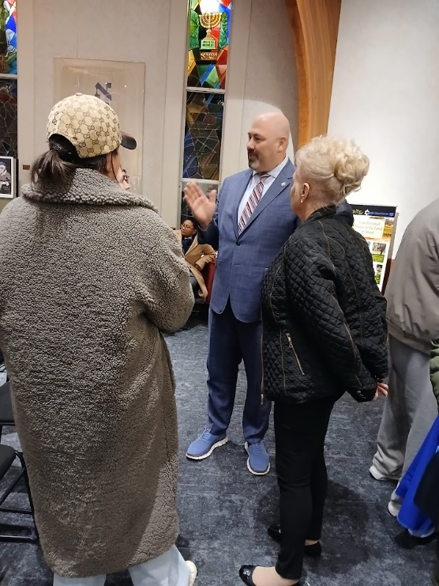
Monmouth County Prosecutor Raymond Santiago, shown talking with residents after the program, told the audience his office employs various means to deal with school bias incidents.
He said he has participated in many such panels recently and has found a “palpable sense” among students fearful of retaliation if they come forward and report an incident.
“We have an express policy against retaliation,” said Krieger and the agency will take reports anonymously.
Reporting is key said Michael Campion, chief of the Civil Rights Division (CRD) of the U.S. Attorney’s Office for the District of New Jersey, because it allows the division to establish patterns of incidents that help to bring about systemic change. The division is tasked with addressing discrimination and segregation under the 1964 federal Civil Rights Act.
However, hate speech is protected by the First Amendment and only rises to the level of a crime if it becomes a threat.
“A hate crime is typically motivated by someone against a protected category such as Blacks, Jews or Muslims,” said Campion, however in schools and elsewhere “someone has the right to be a bigot and spew racist, antisemitic statements. It can turn into a hate crime if someone is giving serious expression to create a hate crime.”
Campion used as an example, a student group chat spreading antisemitism through talk of the Intifada and Zionists. That in itself is not a crime, but if the antisemitic remarks make Jewish students feel like they are the enemy and must be attacked then it could turn into a hate crime.
Iyer said that while “students don’t shed their First Amendment rights at the school house gate,” schools are not powerless to act to tamp down a hostile environment and, in fact, “they may be held liable if they fail to react to hostile speech.”
Schools should immediately call out such speech as antisemitic, he said, adding, “there is no substitution in the aftermath of a bias incident.”

Krieger said schools could be found at fault because permitting a hostile environment could be considered “de facto segregation” covered under civil rights law when Jewish students are prevented from joining clubs, participating in school plays or sports.
However, a school district or college cannot be held liable or have an obligation to respond to incidents it doesn’t know about. Krieger strongly urged reporting be put in writing to avoid the situation of “I told the teacher” that turns into a “he said, she said” situation.
A number of tactics can be employed to counter such incidents, including training of staff, programming, counseling and programs such as the state Attorney General’s Office’s No Hate in the Garden State.
Monmouth County Prosecutor Raymond Santiago said his office looks to counter bias incidents through a number of means, including involving parents and guardians, through programs to change the mindset of youthful offenders through their peers and through its restorative justice program, which focuses on building positive relationships, addressing conflicts through open dialogue and repairing harm caused by negative behaviors, rather than solely relying on punishment,
Iyer urged reporting all bias crimes to local police, the county prosecutors’ offices and downplayed the belief that schools that report a number of bias incidents are failures. Rather they should be praised for responding to the problem.
“I would much rather the incidents be reported than have zero incidents,” he said. “Maybe somewhere there is a school with no bias. I’d like to find it and send my kid there.”
He added that “I’m terrified by what I see but we’re not going to force our way out of it…educating the community is the way.”
Federation plans to hold another such panel discussion in Middlesex in February.
Incidents can be reported to : The Jewish Federation in the Heart of NJ, jewishheartnj.org/incident; CARMA Helpline, carmacenter.org/programs/helpline; Anti-Defamation League, adl.org/report-incident; the NJ Division of Civil Rights, njoag.gov/contact/file-a-complaint; U.S. Department of Education’s Office for Civil Rights, ed.gov/laws-and-policy/civil-rights-laws/file-complaint and U.S. Attorney’s Office, District of NJ, justice.gov/usao-nj/civil-rights-enforcement.

Debra Rubin has had a long career in journalism writing for secular weekly & daily newspapers and Jewish publications. She most recently served as Middlesex/Monmouth bureau chief for the New Jersey Jewish News. She also worked with the media at several nonprofits, including serving as assistant public relations director of HIAS and assistant director of media relations at Yeshiva University.

