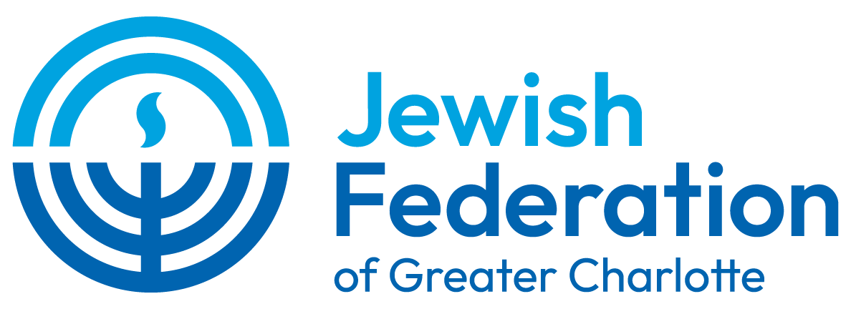



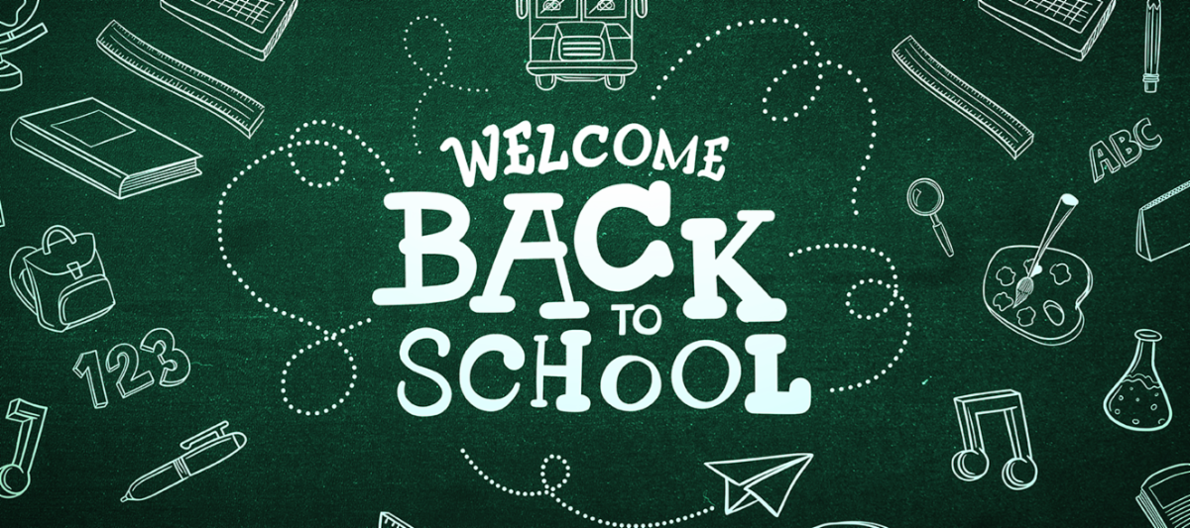

Dear Parents,

With the start of a new school year comes the excitement of new teachers, new classmates, and new opportunities to learn. Jewish Federation of Greater Charlotte and its Jewish Community Relations Council (JCRC) wishes all of our students a safe, healthy, and successful year ahead!

Our Shared Commitment

The JCRC builds relationships throughout the greater Charlotte community and advocates to elected officials and leaders on behalf of the Jewish community. We work year-round with both Charlotte Mecklenburg Schools (CMS) and Union County Public Schools (UCPS) to promote diversity, equity, and inclusion in the public school system and to educate them on our community's needs. Both school systems have been responsive, and we are grateful for their continued support.

As we prepare for the High Holidays in September, we look forward to coming together as a strong, united Jewish community to celebrate and worship.
﻿
Calendars

We encourage you to communicate with your child's teacher as early as possible about the religious holidays your family observes and how they may affect your child's participation in the classroom. This year, most major holidays fall on weekends, with the exception of Yom Kippur, Purim, and Passover.

Jewish Holiday Calendar — share with teachers and administrators to explain absences or to advocate for religious accommodation and sensitivity in scheduling exams and school events.
CMS 2026-2027 Traditional Calendar
UCPS 2026-2027 Traditional Calendar

Please note: Rosh Hashanah begins at sundown on Friday, September 11, and concludes at sundown on Sunday, September 13. For both CMS and UCPS, Friday, September 11, is a regularly scheduled school day. Yom Kippur begins at sundown on Sunday, September 20. Monday, September 21, is a teacher workday for both CMS and UCPS; however, UCPS designates it as an optional workday rather than a required one.

Resources for Parents & Families

The following resources are intended to help families navigate conversations with their child's school, understand district policies, and access tools for responding to antisemitism.

Talking with schools and children about Israel and Judaism:

StandWithUs Educational Booklets
ADL Table Talk: Family Conversation Guide
ADL Back to School Resources
AJC Toolkit for Parents of K-12 Children
Be Your Child's Advocate (Scholastic)

For parents of children in Mecklenburg County public schools (CMS):

CMS Non-Discrimination Policy
CMS Policy on Religious Accommodations (Policy ACD, Nondiscrimination on the Basis of Religion / Religion in Schools)
CMS Bullying Policy (S-BULY)
CMS Bullying Prevention Regulation (S-BULY/R)

For parents of children in Union County public schools (UCPS):

Board of Education Policies (Refer to policies 3-07 and 4-07 for the Prohibition Against Racism, Unlawful Discrimination, Harassment and Bullying policies)
UCPS Policy on Religious Exemptions From School Programs

What To Do if You Encounter a Concern

If your child experiences an antisemitic incident at school, we encourage you to take the following steps:

- Speak with your child's teacher or guidance counselor as soon as possible.
- If the matter is not resolved in a timely manner, contact your school's administrators (Assistant Principal or Principal).
- Submit a report to your school district: CMS or UCPS.
- Report the incident to the ADL.
- Reach out to Douglas Greene, Jewish Community Relations Director at Jewish Federation of Greater Charlotte, for additional support.

If you are unsure if an incident qualifies as being antisemitic, please c. Even when an incident may seem minor, sharing your concerns helps us better understand what's happening in our schools and determine how we can best support your family.

Looking Ahead Together

As your children venture into another school year, please contact us if and when you need assistance. We are here to support you and your child's educational experience in public or private schools across our region.

With gratitude and partnership,

Jewish Federation of Greater Charlotte

